Software Systems Development
AS2 Design Document
Physics Quiz

Contents
Game Background 4
User Requirements 6
Draft 1 Storyboards 7
Splash screen form 7
Sign up form 8
Log in form 9
Main Menu 12
High Score form 13
Question 1 14
Question 2 16
Question 3 18
Question 4 19
Question 5 21
Quiz Review 22
Draft 2 Storyboards 23
Splash screen form 23
Sign up form 24
Log in Form 25
Main Menu 26
High score form 27
Question 1 28
Question 2 29
Question 3 30
Question 4 31
Question 5 32
Quiz Review 33
Final Draft Storyboards 34
Splash screen form 34
Sign up Form 35
Log in form 36
Main Menu 37
High Sore form 38
Question 1 39
Question 2 40
Question 3 41
Question 4 42
Question 5 42
Quiz Review 44
Class Designs 45
Question class 45
Reg exception class 48
Player Class 49
Program Class 53
Testing 0
Test No. 0
Form 0
Test Description 0
User Req. 0
Test Data 0
Expected Outcome 0
Pass/Fail 0
Evidence 0
Pass/Fail 16
Corrective Action 18
Evaluation 0
Analysis of User Requirements 0
Survey Feedback 4
Strengths 7
Weakness and Improvements 8
Improvement 1 8
Improvement 2 8
Improvement 3 8
Improvement 4 9
Improvement 5 9
Time Management 11
Skills Development 12
Writing to and reading from bin files 12
Reading questions from a .txt file 12
Drag and drop 12
Movement keys 12
Validation 12
Load Events 12
Appendix 14
Blank Survey 14
Completed Surveys 19
End User surveys 19
Client Survey 53

Game Background
My Physics teacher Mr Kenady asked me to create this program to allow students to do practice questions on the different topics of a level Physics. The program will need to consist of 5 different quiz games each functioning in a different way such as question 1 which will a simple multiple choice game where you are asked 5 different random questions and have to select the correct answer to gain score which will be used to calculate the total score at the end of the quiz which will then be put on the high score screen for other people to see.
To make sure that the requirements of my teacher were met the sign-up process will allow the users to all create their own accounts with their own separate usernames and passwords which will all be saved to the one binary file so that the information can easily be read back into the program to be used at a later time.
After creating the sign up process I then chose to create a main menu that will allow the user to easily navigate the program and access a high score form that will allow the user to compare their score to others the main menu will also have a list of the top ten scoring players to incentivise the user to try and get as high of a score as they can in the quiz.
When creating the questions I want all of them to have unique mechanics to make the quiz more interesting and for the questions to appear in a random order so that the user doesn’t get asked the same questions if they play the quiz a second time so that it isn’t easy to learn the answers to get the top score.
I want to make sure that there are some questions that have a time-based mechanic so that the user is pushed to answer as many questions as possible within a time constraint and they can potentially get more time if they get answers correct so that they are pushed to try and get the correct answers instead of just guessing.
After the user finishes the quiz they should go to an additional form so that the they can see how well they did on every question and receive feedback on what they need to improve as well as allowing easy access to the high score form. I will make message boxes that appear if the user achieves certain scores and if the user achieves a new high score a message box will appear telling them that they got a new high score as well as telling them what they got.
In the program I will implement a menu strip to allow the user to navigate the program easier and display important information such as how long they have left in the timer-based question and giving them access to short cuts to certain parts of the program such as going back to the main menu from any of the questions.
In one of the questions, the user should be able to interact with it with the arrow keys on the keyboard to move their avatar around the question and navigate to a certain answer to gain score.
After the user answers a question, I also want them to receive a message box telling them how they did in that specific question.
When the user is navigating the form, I want there to be a certain order that the user accomplishes goals so that they can go through the form in the correct order without breaking the sequence that the program is supposed to flow in.
Finally, the user should be able to log out of the program so that other people can sign in and use it without the program having to be fully reset so to accomplish this there will be a button on the main menu and menu strip allowing the user to log out from anywhere in the program it will work by setting the current logged in user equal to null.

User Requirements
- The user must be able to pass through the entire program in the correct order
- The user must be able to create an account with their details such as a date of birth
- The user must be able to interact with the program by using certain keys
- The user must be able to access help by pressing the help button in the menu strip and it mustn’t affect the user ability to complete the program
- The user must know their username and password to enter the program
- The user mustn’t be able to get stuck in the program
- The program must save the users choice of avatar and username for later use
- The user must be able to log out of the program
- The user should be able to compare their score to others that have completed the quiz
- The user must be able to randomize of the program that wouldn’t affect the progression
- The user should be able to answer the random questions in question 1
- The user must be able to go back to the main menu from almost all the places in the program
- The user should be able to drag and drop the answers in questions 2 and 3
- The user should get random questions that don’t appear twice in a row
- The user must be told if there was something wrong with the info they tried to create an account with
- The user will be asked a new random question once they answer one
- For some questions in the quiz the user should be timed
- The program will notify the user if they get a new high score
- The user will get told how they did in each of the questions in the quiz review
- The user will get feedback depending on how they performed in each question after they compete it
- The user should be able to go back to where they left off in the quiz.
- The user should be able to keep their log in details private.
- The user should be able to close the program from almost any form
- The user should be able to keep track of their score throughout the quiz

Draft 1 Storyboards

Splash screen form
For the splash screen there should be the name of the company in lblTitle and an animated loading screen (pbxLoadingGif) that plays for 5 seconds before the program opens
There should be a way for the program to tell if the user hit the enter key and if they did the timer would stop and the user would be taken to the sign-up form right away without having to wait this fulfils part of user requirement 3 that the user should be able to interact will the program with certain keyboard presses.
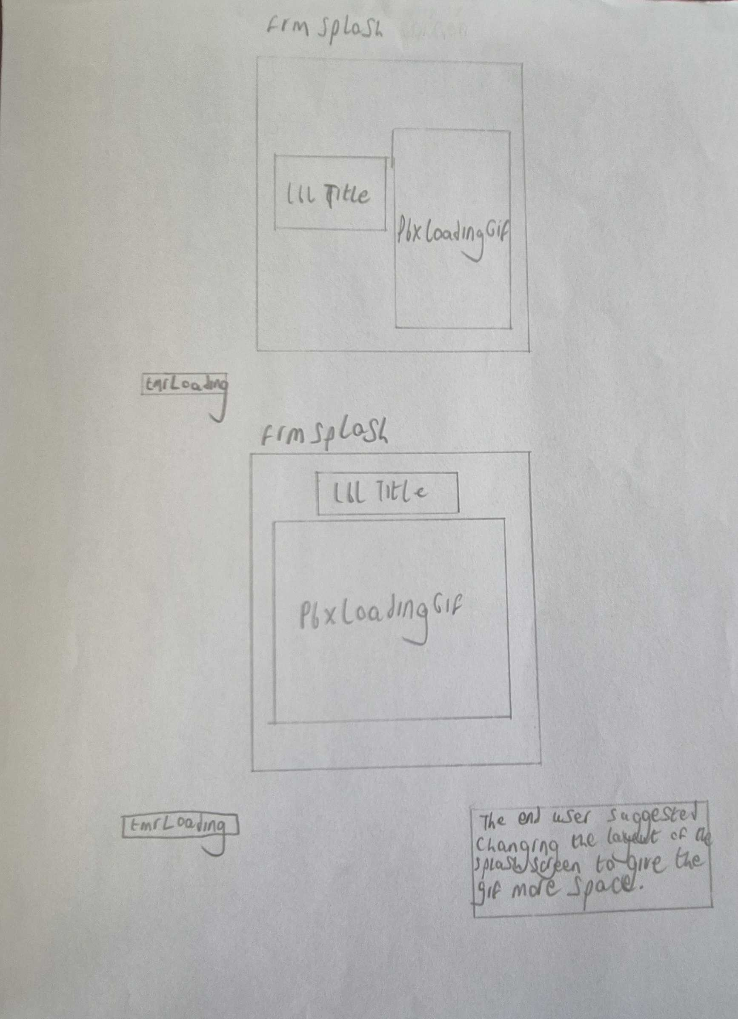

Sign up form

The sign-up form is the first form in the program that requires user input to move onto the next form and is accessed after the splash screen closes. The sign-up form should contains everything the user needs to create an account (see layout). The user can enter the username they want in tbxUsername and their password in tbxPassword they can also select an avatar from the 4 available by clicking on the one they want (pbxAvatar1-4), and they can enter in their date of birth into the date time picker
After the user has entered all the information that the program requires, they can click btnSubmit. After clicking the button the details that the user entered go through validation to make sure that they meet the requirements such as the username and password and be shorter than 8 letters and can’t be longer than 20 letters and the password must contain at least one letter and number after this validation the details are checked against existing users in the player list file to make sure that the username and password don’t match that of another users and if the details pass all of the checks the details are saved to playerlist.bin( this allows the completion of user requirement 2 that the user should be able to create an account).
However, if the details that the user enters doesn’t pass through the validation then a message box will appear on the screen telling the user what is wrong with the details they entered and then the form will be reset to its original state.
There will also be btnLogIn which allows the user to skip the sign-up process if they have already created an account prior this takes the user to the log in screen and closes the sign-up form.
On the menu strip of the form there will be btnHelp which can assist the user if they are struggling to figure out what to do and causes a message box to appear telling the user that they must fill in the details required the create an account and the requirements for formatting the username and password such as how long they need to be.
The form will be split up into two sections one being held on a panel (pnlSignUp) and the other outside of the panel. On the panel is all of the textboxes for the username and password and anything else the use has to fill in to create an account and outside of the panel are buttons to submit the details entered and to go to the log in screen they are split up to make the form look tidier as it is less cluttered having everything split between two parts instead of one. There will also be as little text as possible to make it easier to understand.

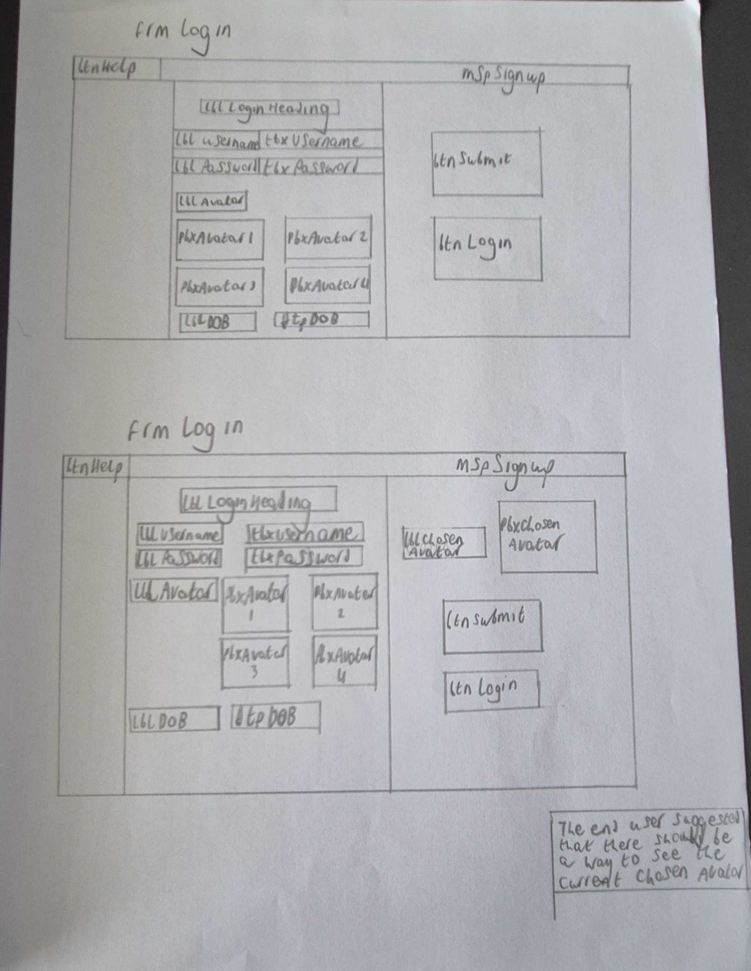
Log in form
The log in form will be the second form that the user can access after the splash screen closes. The log in form contains all of the necessary features that the user needs to log in to their account such as a place to enter their username (tbxUsername) clearly marked by lblUsername next to it with the text “Username:” and another textbox for the password (tbxPassword) clearly marked by a separate label (lblPassword) with the text “password”.
When the user enters a username and password there are three things that can happen when the user clicks btnSubmit the text that they entered into the textboxes is compared to the text in the playerlist.bin and if the username and password entered both match that of an already existing user the details will be accepted and the user will be taken to the main menu form and the logged user object will be set to the account that the user just logged into( this allows the completion of user requirement 5 that the user should know their username and password to be able to enter the program).
However, if the user didn’t enter the correct details, then when they click the submit button their username and password won’t match any existing user causing a message box to appear telling the user that they entered the wrong username and password before the form is reset to its original state and the user must try again. If the user tries to log in and doesn’t enter any information, then a different message box will appear telling the user that they need to enter a username and password allowing the user another chance to enter them.
The form will also contain a button that allows the user to go back to the sign-up form in case they went to the log in screen before creating an account (btnSignUp) this allows the user not to get stuck on the log in screen and have to reset the program (fulfilling user requirement 6 that the user can’t get stuck in the program) as they can go back to the sign up form and then create an account to log into in the log in form.
When the log in form opens If there is already information saved to the logged user object the program will take the username and password and place them into the correct textboxes allowing the user to save time and not have to enter in their username and password again if they just created the account.
There will also be btnHelp on the menu strip of the form that allows the user to cause a message box to appear telling them that they have to enter their username and password into the appropriate textboxes in the form to log in.

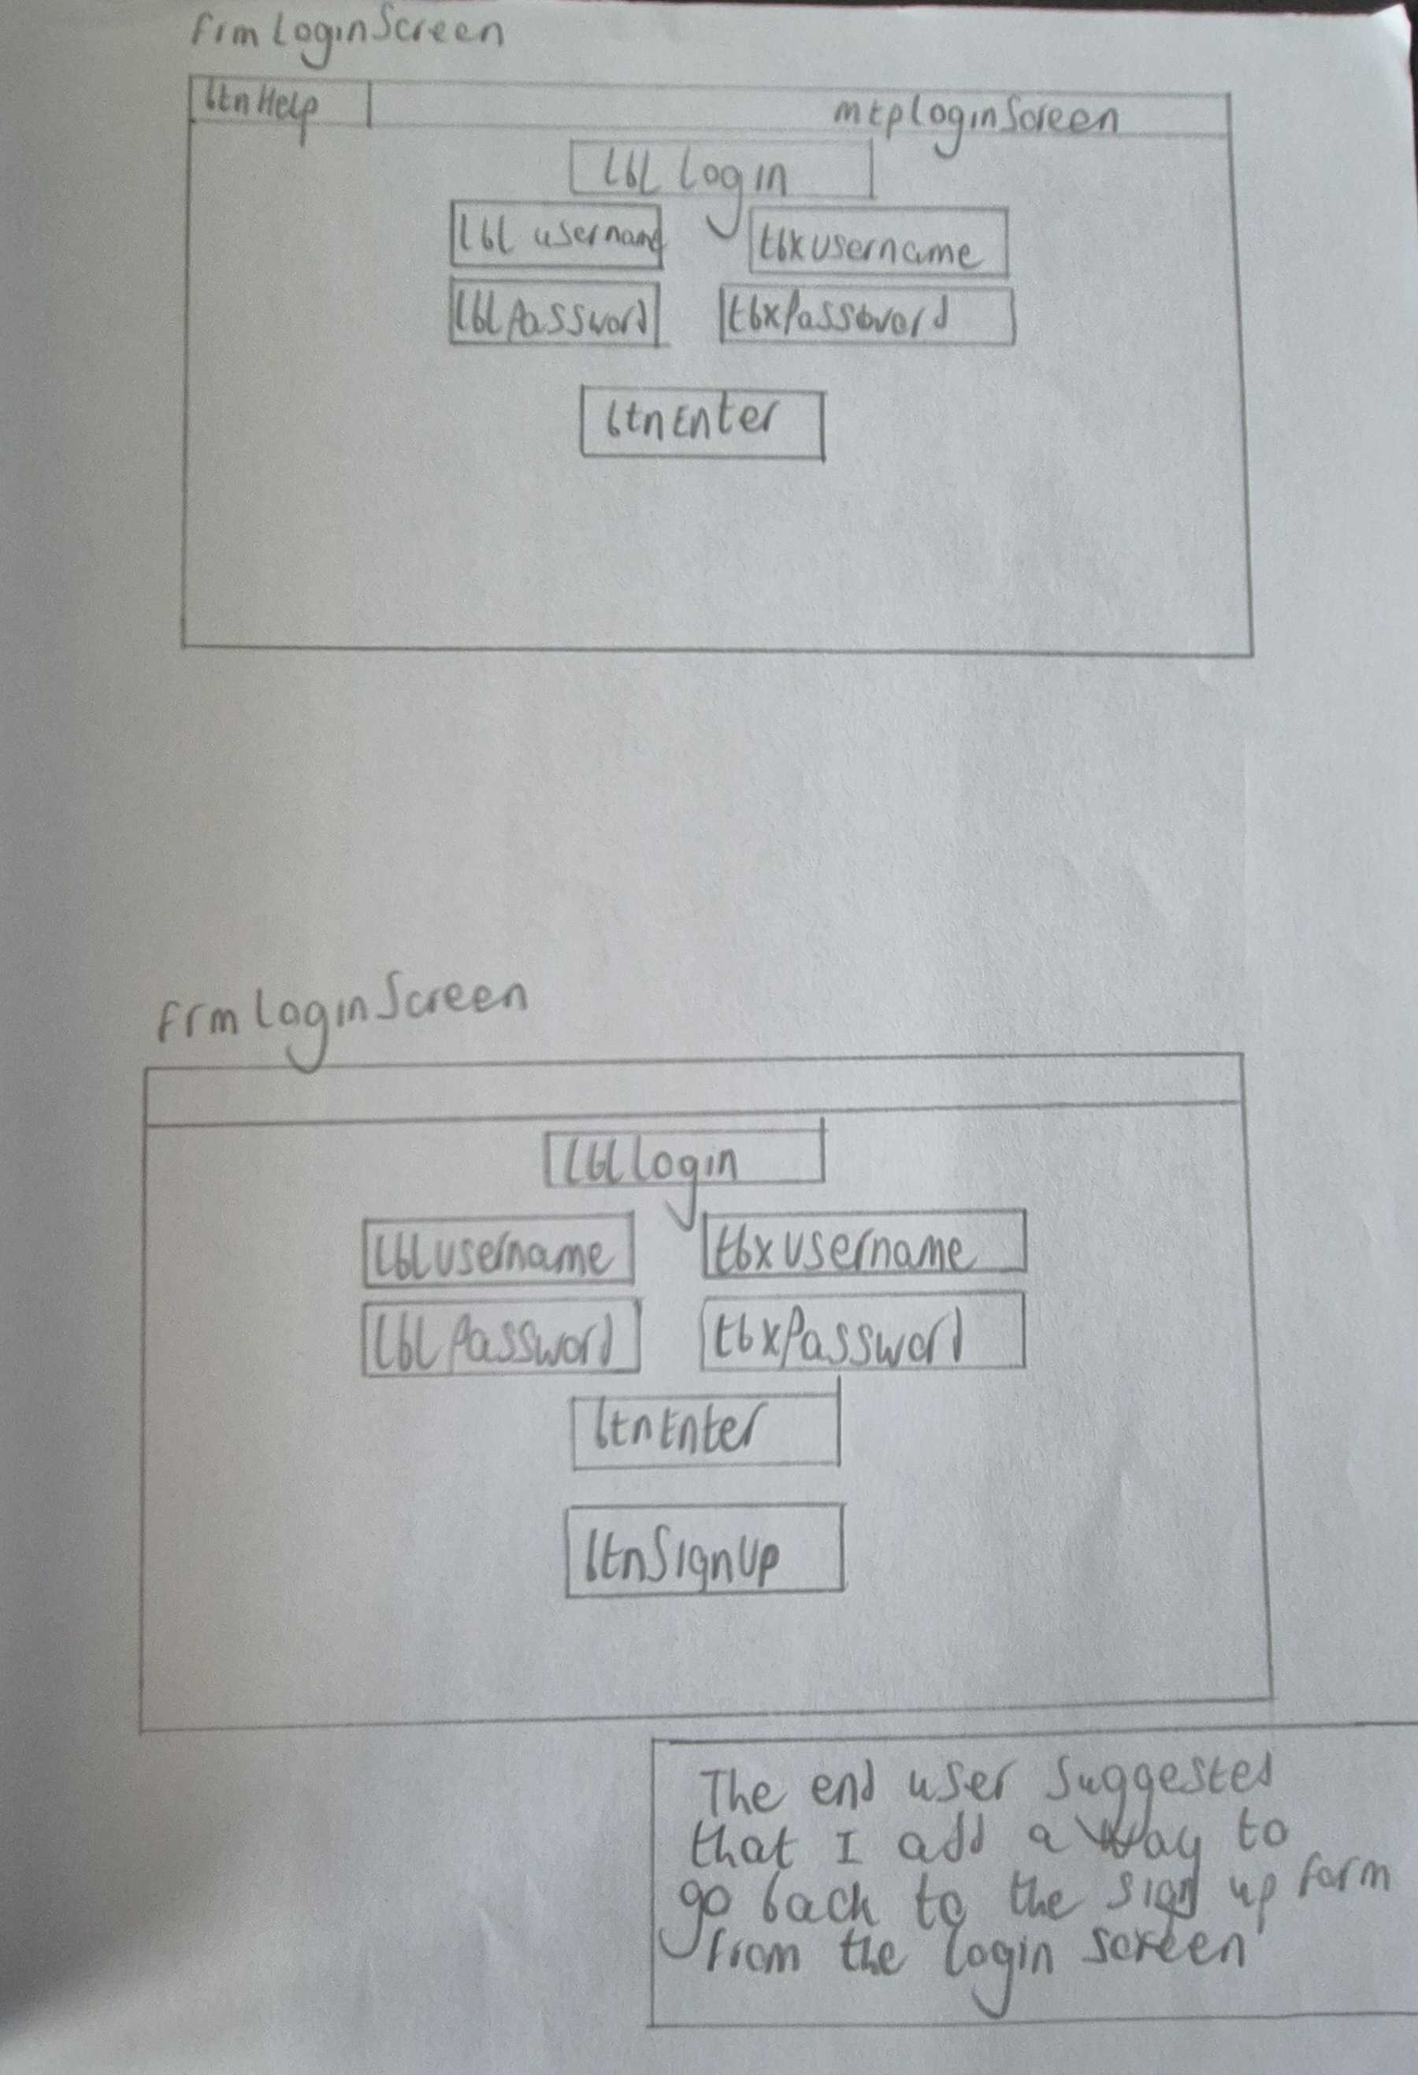

Main Menu
The main menu form will be the first form that the user encounters after they create an account and log in. It is the main part of the program where the user can access the quiz, high score screen, the quiz review and log out from.
The main menu will contain btnQuiz which sets the users current score to 0 for all the questions in case the user had already started the quiz and takes them to question 1.
The main menu will also have btnHighScore where the user can be taken to the high score form to see what other people got in the quiz.
btnLogOut sets the logged user object equal to null and takes the user back to the log in screen (completing user requirement 8 that the user should be able to log out of the program).
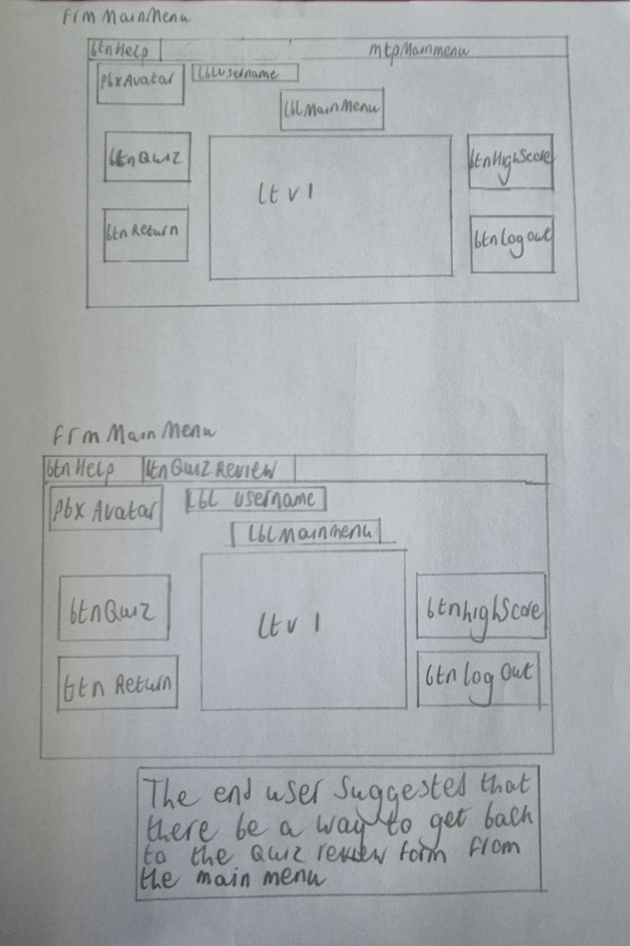
btnReturn checks the last form variable stored in the logged player object and depending on what it was it sends the user back to that question in the quiz and sets the user score for that question equal to 0 (This completes user requirement 21). There is also a button on the menu strip labelled “Quiz review that allows the user to back to the quiz review form to see how they did in the quiz even after they exit it if they have a score for question 5 (this competes user requirement 1).

High Score form
The high score form will be accessed by a button in the main menu and allows the user to view the high scores of all the other users in the player list file.
The form will include 2 buttons, and a list view the first button is btnBack that takes the user back to the main menu form and the second button is btnRandomize that changes the order that people are displayed in on the list view (ltv1).
The list view displays the high score of every player in no particular order.
The high score form allows the user to compare their score to others that have completed the quiz (This accomplishes user requirement 9 the user should be able to compare their score to others)
This form should also contain a menu strip that contains a help button that tells the user exactly what they can do on this form.
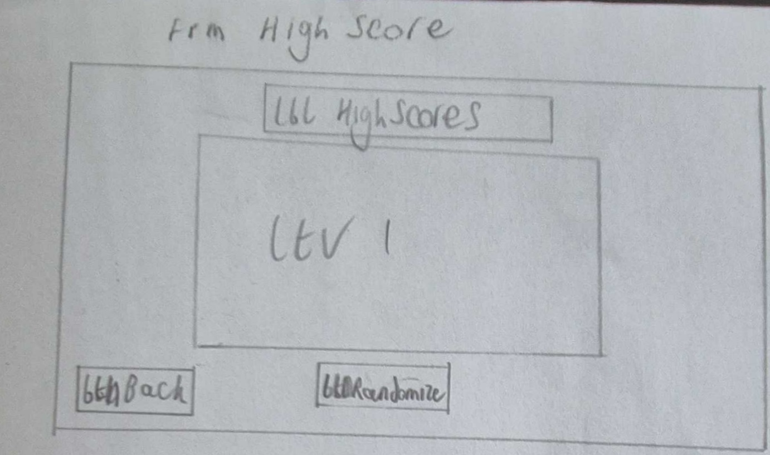

Question 1
The first question of the quiz will be accessed by pressing the quiz button on the main menu and consists of 4 buttons and a label (btnAns1-4 and lblQuestion)
When the form opens the program will use a randomize list method to randomize the order of the questions in question1.txt so that the user is given a different set of questions each time they do the quiz after the list is randomized the program splits the text based of where there is a comma into the question and the 4 different answers with the first being the correct it then creates the question object using this information for the player to be asked.
The label displays the text of the current random question taken from the question 1 text file.
The buttons all display random answers related to the question that appears on the label and if the user selects the correct answer the user is given 2 points towards score 2 and the current question variable increases by one. The question will also reset to another random one from the list every time a question is answered.
If the user got the question incorrect a message box will appear on the screen telling the user that they got the incorrect answer, and the question will reset without the player gaining any score.
When the player answers 5 different questions the program will user the players score for question 1 to give them a review depending on how they did, and the user will be taken to the question 2 form.
The user can also click btnReturnToMainMenu to go back to the main menu and the program saves a string that can be used in the main menu to return to question 1 form by pressing the return to quiz button.
The form should also contain a label on the menu strip that tells the user their total score so that they can keep track of it throughout the quiz.
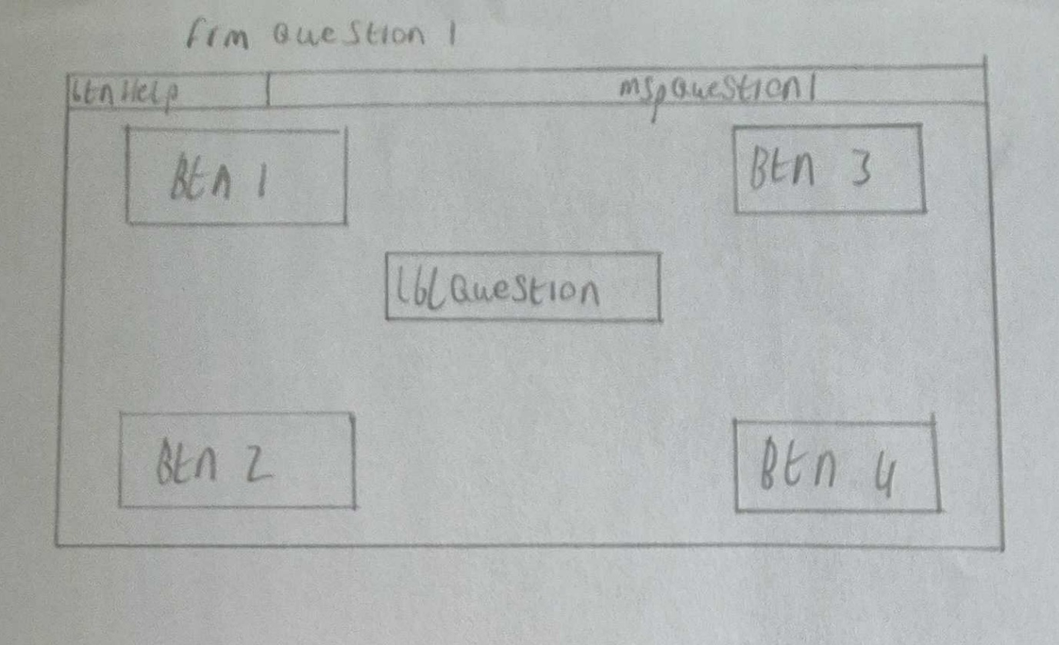

Question 2
The second question of the quiz will be accessed after the user answers 5 questions in the first question. The question 2 form contains 6 picture boxes 3 for holding images(pbx1-3) and 3 for dropping images into (pbxAns1-3) it also contains a label that gives the user a question and a button that allows the user to check their answer.
The 3 picture boxes (pbx1-3) containing images have a drag and drop (This partially completes user requirement 13 the user should be able to user the drag and drop mechanic to answer questions 2 and 3) feature that allows the images to be dragged and placed in the other 3 image boxes (pbxAns1-3) that change the image that they display to whatever image was dropped into it and will save the user answer in another variable that is checked whenever the user presses the check answer button.
When btnCheckAnswer is clicked it will use the user answer array to check each variable in a for loop against the correct order that the images are supposed to be in and then for each one in the correct place 1 point is added if at the end of the for loop the user has 3 points they are awarded 3 score for question 2 however if they don’t have 3 points then the answer is marked as incorrect and a message box will appear telling the user that they got the question incorrect and they will gain 0 score.
Once the user has answered 5 questions on this form they will be taken to the third question and their score for question 2 will be saved and used to find the correct review for how the user did in question 2.
The user can also go back to the main menu from the second question by pressing btnReturnToMainMenu in the menu strip which saves a string that allows them to go from the main meu to question 2.
The form should also contain a label on the menu strip that tells the user their total score so that they can keep track of it throughout the quiz.

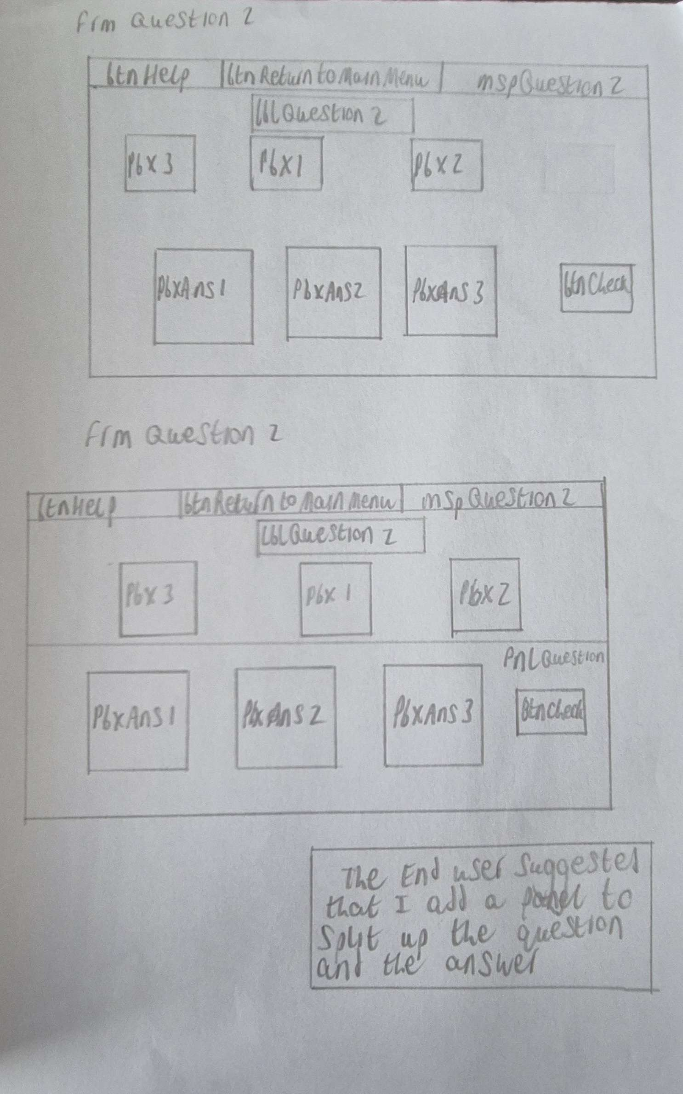

Question 3
The third question form will be accessed after the user completes 5 questions in the question 2 form. This form will consist of 6 labels in the top half one of which being the question (lblQuestion) and the other 5 being answers that the user can drag (lblWord1-5). The bottom half consists of 10 labels and one button the 5 labels on the left (lblText1-5) are the statements that the user needs to match the correct answer too and the 5 labels on the right (lblAnsLine1-5) are the spots that the user can use to place the answer onto with one corresponding to each statement. btnCheck allows the user to check their answer after they slot the 5 answers into the corrosponding answer lines.
If the user places all of the answers in the correct place, then the program will give them 5 points when the for loop is over which allows another if statement to grant them 5 score and a message box will appear telling the user that they got the question correct. However, if the user doesn’t get 5 points when they click the check answer button then they will not get any score, and a message box will appear telling the user that they got the answer incorrect.
No matter how the user answers the question after the check answer button is clicked the question will be reset with a different question, so the user doesn’t have to answer the same questions multiple times in a row.
Once the user answers the fifth question on the form then they will be taken to the fourth question and their score for that question will be used to give a review on how they did.
The user can press btnReturnToMainMenu on the menu strip to be taken back to the main menu and a string will be saved to the last form variable inside the player object so that they can return to the question they were on with btnReturn in the main menu.
The user can also receive help on the form by pressing btnHelp that will be on the menu strip that will give them an idea of what they are supposed to do on the form without giving them any answers
The form should also contain a label on the menu strip that tells the user their total score so that they can keep track of it throughout the quiz.
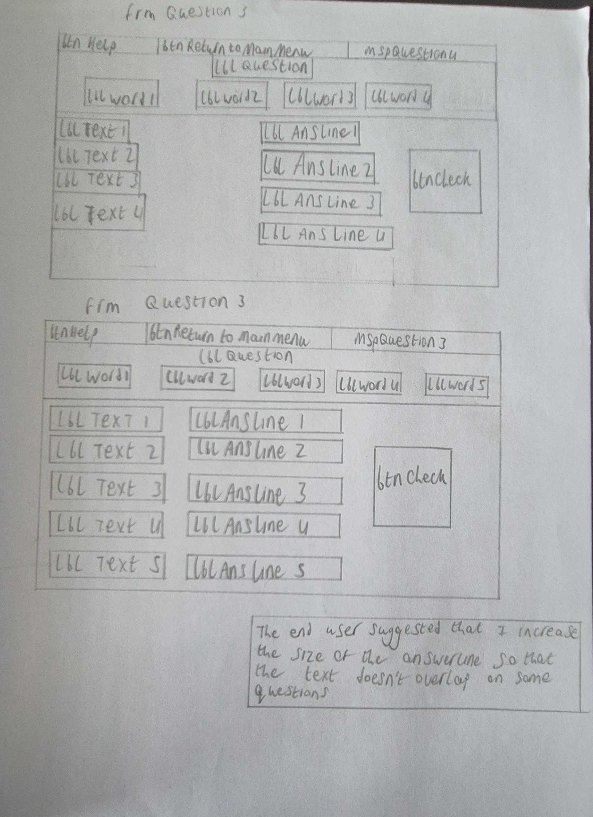

Question 4
The fourth question in the quiz will be accessed after the user has answered 5 questions in the question 3 form and will consist of 5 picture boxes- pbxAns1, pbxAns2, pbxAns3, pbxAns4 and pbxAvatar. There will also be a label- lblQuestion which displays the current question from Question4.txt. all the answer picture boxes are in the 4 corners and the picture box containing the avatar is in the centre of the form there will also be a panel containing lblQuestion which will allow the form to stay less cluttered and allow for the question to be separate from the game section of the question.
The main mechanic about the fourth question will be that the user is supposed to move their avatar about the form with the arrow keys and navigate it to whatever image they want to answer the question with. If the user navigates their user to the wrong answer a message box will appear on the screen telling the user, they got the answer incorrect, and the position of the avatar will be reset to the centre of the screen before the question is reset.
However, if the user navigates the avatar to the correct answer a message box will appear telling the user that they got the question correct and 2 points will be added to the user score for question 4. The question will then be replaced with another random question from Question4.txt.
The user can press btnReturnToMainMenu on the menu strip to be taken back to the main menu and a string will be saved to the last form variable inside the player object so that they can return to the question they were on with btnReturn in the main menu.
The user can also receive help on what they need to do on the form by pressing btnHelp on the menu strip of question 4 which will cause a message box to appear telling the user what they are supposed to do on that form.
The form should also contain a label on the menu strip that tells the user their total score so that they can keep track of it throughout the quiz.
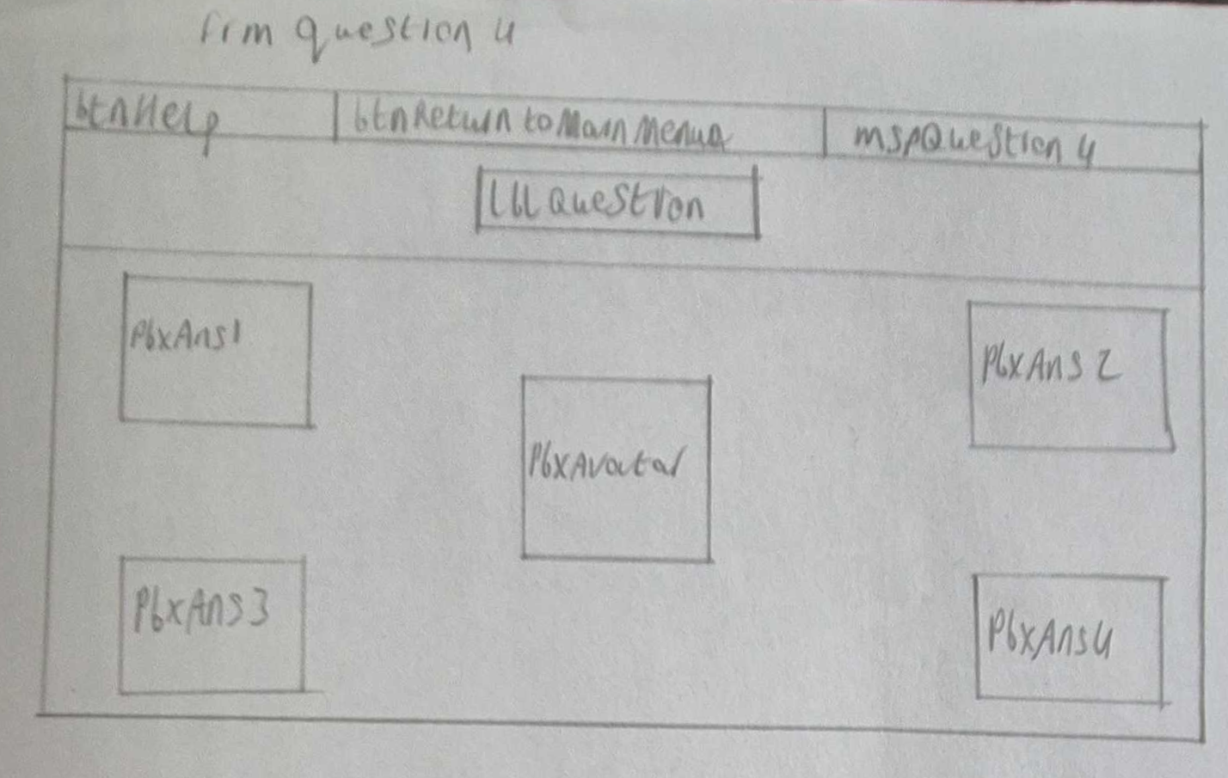

Question 5
The fifth question will be accessed by the user after they answer 5 questions in frmQuestion4 and will consist of 2 buttons- btnTrue and btnFalse and one label which displays the current question (lblQuestion) and a countdown label on the menu strip lblCountdown.
The premise of the question will be that the user will have 20 seconds to answer as many questions as possible within the time limit and the moment the time reaches 0 the question ends, and the user is taken to the next form.
If the user answers a question correctly, they will gain 2 points towards the question 5 score and they will also gain an additional 1 second towards the timer to allow them to answer more questions.
If the user answers a question incorrectly, they won’t gain any points, and the timer will be decreased by 3 seconds. The difference in how much is gained and lost is due to the fact that if it was equal the user would be able to guess the same answer over and over and be able to answer all of the questions before time ran out and get near half of the score with no effort.
The countdown will be manipulated by tmrCountdown which ticks every second and every time it does tick it changes the text in lblCountdown by decreasing the number by 1.
the only 2 ways to get passed question 5 are to wait for the timer to reach 0 or to answer all 15 of the questions which causes the form to display a message box telling the user that they have answered all of the questions in the form and moves them to the quiz review form.
The form should also contain a label on the menu strip that tells the user their total score so that they can keep track of it throughout the quiz.
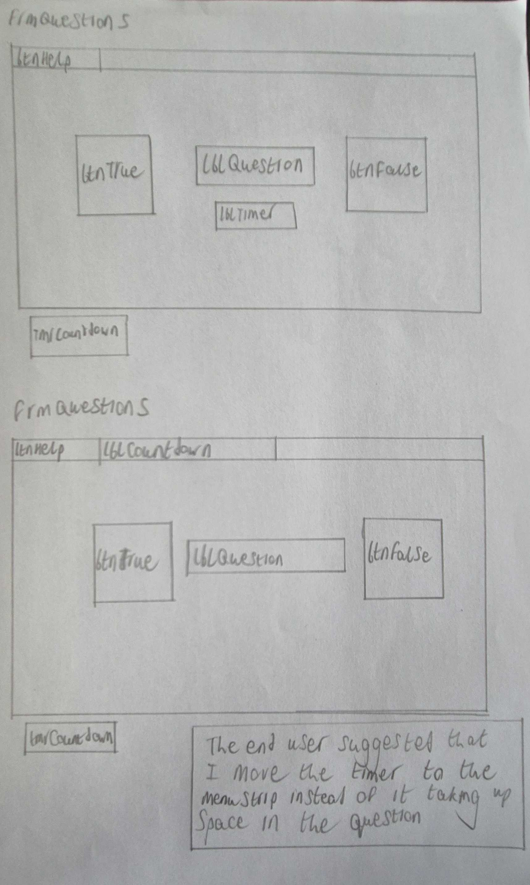
There should also be a help button on the menu strip that when pressed it will tell the user what they are supposed to do on that form.

Quiz Review
The quiz review form will be accessed by the user after they have competed the quiz. The quiz review form will consist of 2 buttons – btnMainMenu and btnHIghScore. It also has 12 labels – lblQ1Result – lblTotalResult and lblQuiz1 – lblQuiz5 there is also lblTotal. The purpose of the form is to allow the user to see how they achieved by displaying how the user did in each individual question in the result labels such as lblQ1Result and giving the user a review for how they did in the questions that is displayed in the lblQuiz.
btnMainMenu button will allow the user to go back to the main menu form where the user will be able to start the quiz again or because they will now have a score for question 5, they can go back to the quiz review form using btnQuizReview in the menu strip.
The user will also be able to use btnHighScore to go back to the high score screen to compare how they did to others in the program.
When the form opens it will run code that checks to see if the users current total score is higher than the user high score and if the total score is bigger then it will replace the high score and write the new information to the file.
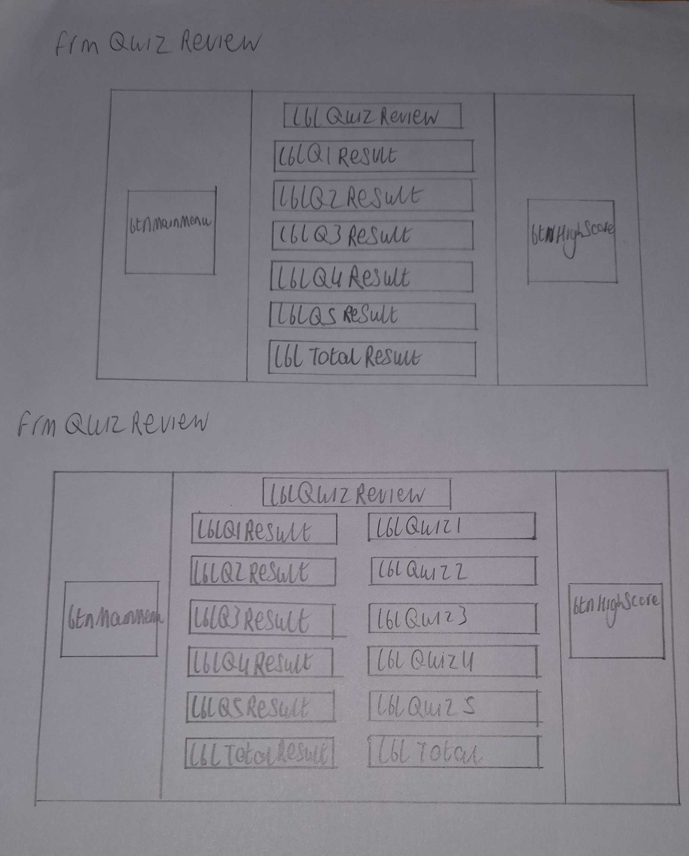
This form should also contain a menu strip that contains a help button that tells the user exactly what they can do on this form.

Draft 2 Storyboards

Splash screen form

Sign up form
My teacher requested that the user should have some way to see what avatar they have selected so to accomplish this I added a picture box that displays the users chosen avatar and updates every time the user selects a new one so that the user will know what avatar thy have selected when they create an account instead of not having a way to know until they see it later in the program.

Log in Form
For the second draft of the log in form my teacher requested that I add a way for the User to go back to the sign-up form from the log in screen to make sure that the user didn’t get stuck when going through the program so to accomplish this I added a button that would take the user back to the sign-up form

Main Menu

High score form
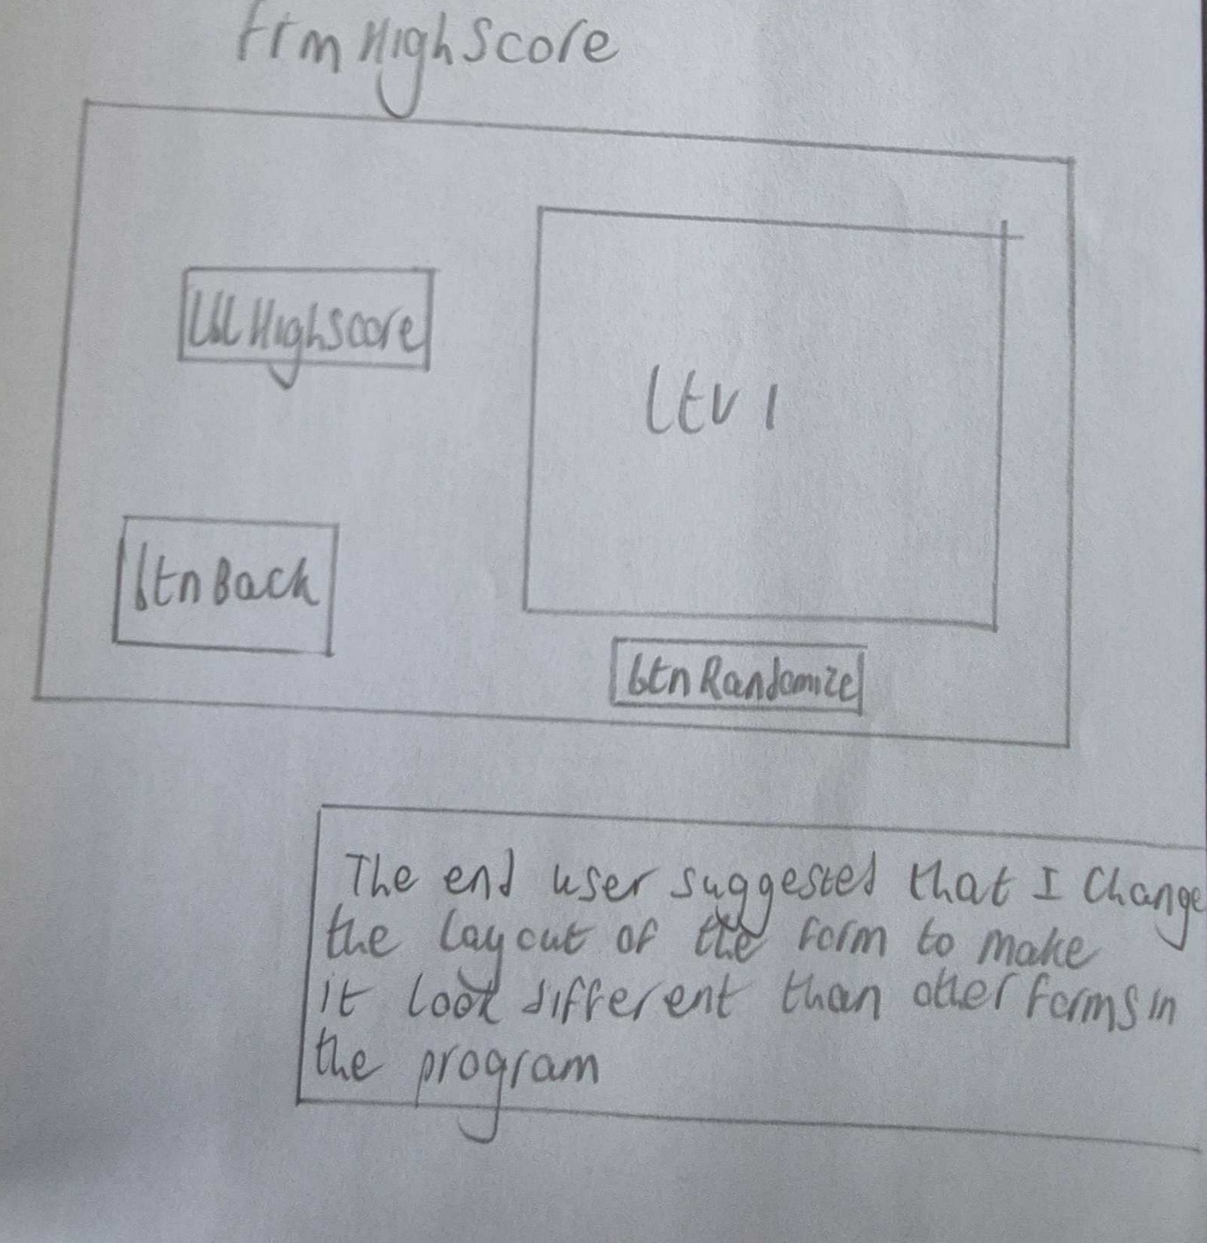

Question 1
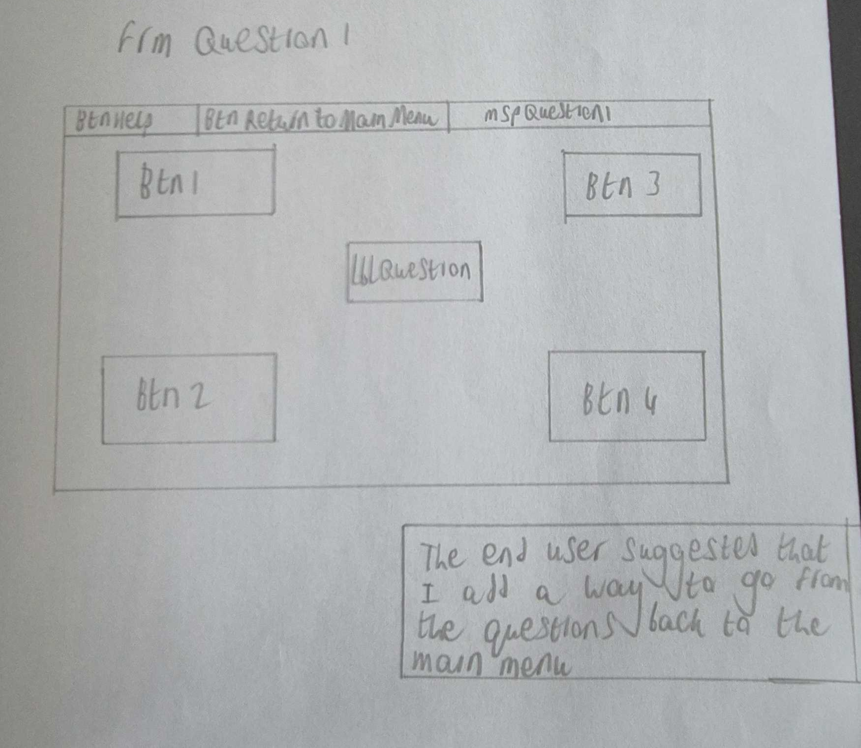

Question 2
The end user suggested that I add a panel to split up the two sets of picture boxes so that the form looks more organised and to split it into a question half and an answer half to make it easier for the user to understand the premise of the question

Question 3
For the second draft of the third question, I decided to add a fifth statement to make sure that I made the most of the space on the form. The end user also suggested that I make the answer lines bugger and increase the space between the answer line and the statement so that they don’t overlap when certain questions were being displayed.

Question 4
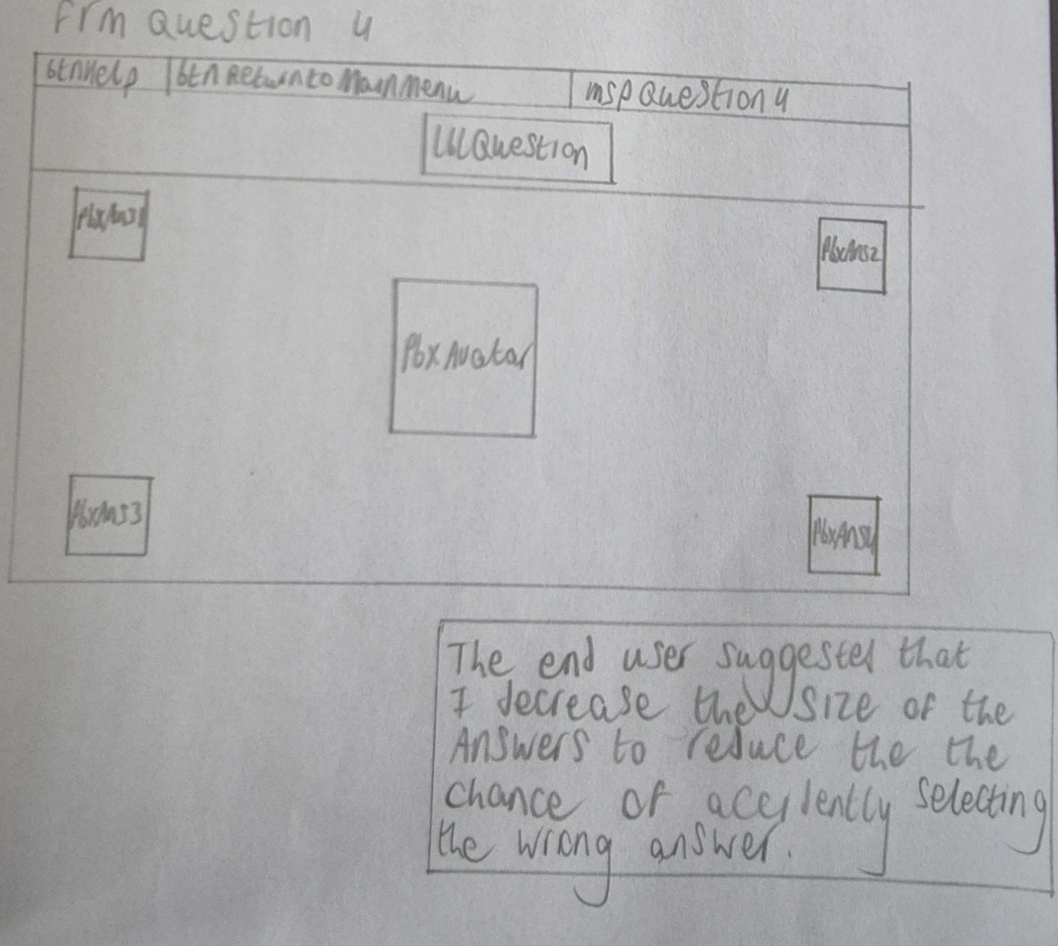

Question 5

Quiz Review
The end user suggested that I increase the size of the panel that holds the reviews to make sure that the information doesn’t overlap and that I should add text that holds the reviews so that the user can tell how they did in each form.

Final Draft Storyboards

Splash screen form
The gif in pbxLoading is “Loading.gif”
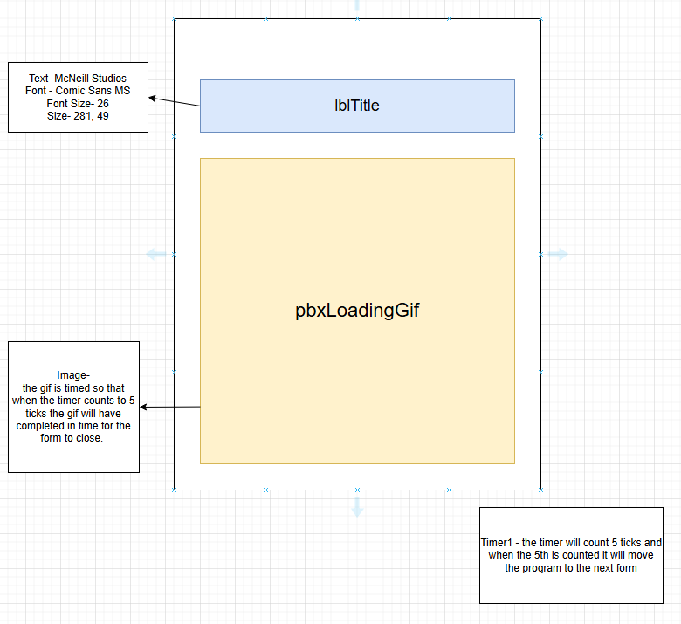

Sign up Form
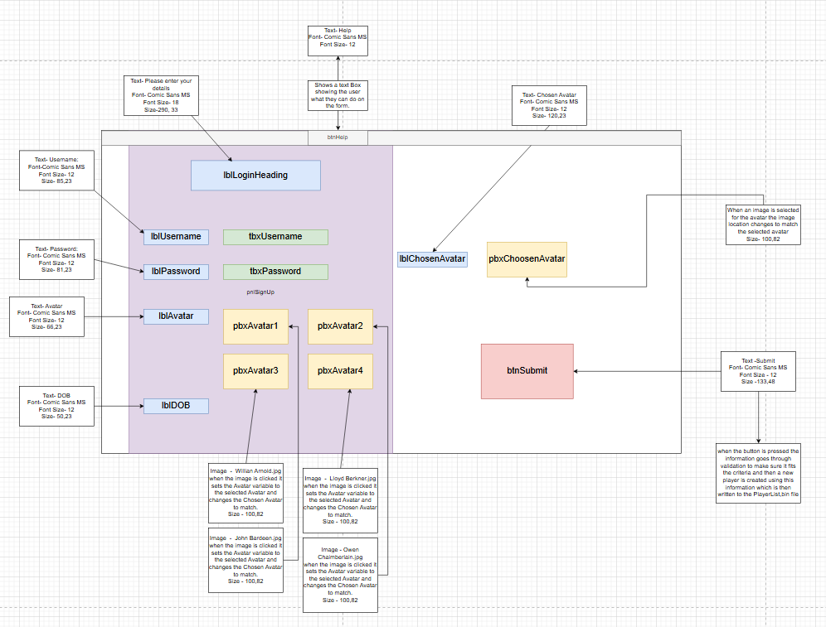

The information that it checks the users input against comes from PlayerList.bin

Log in form
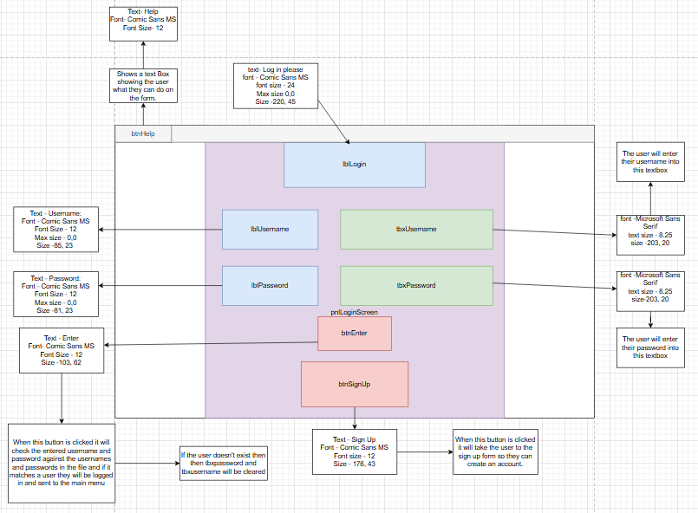
The information that it checks the users input against comes from PlayerList.bin

Main Menu
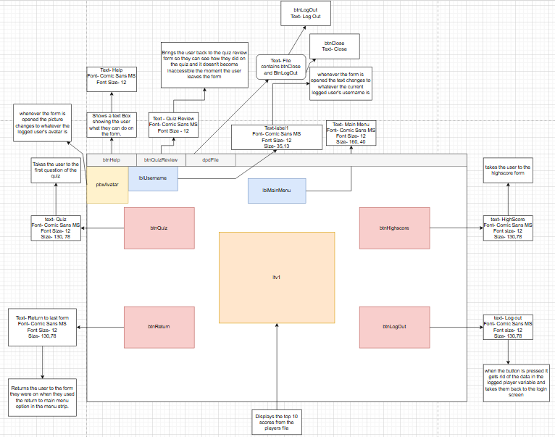

High Sore form
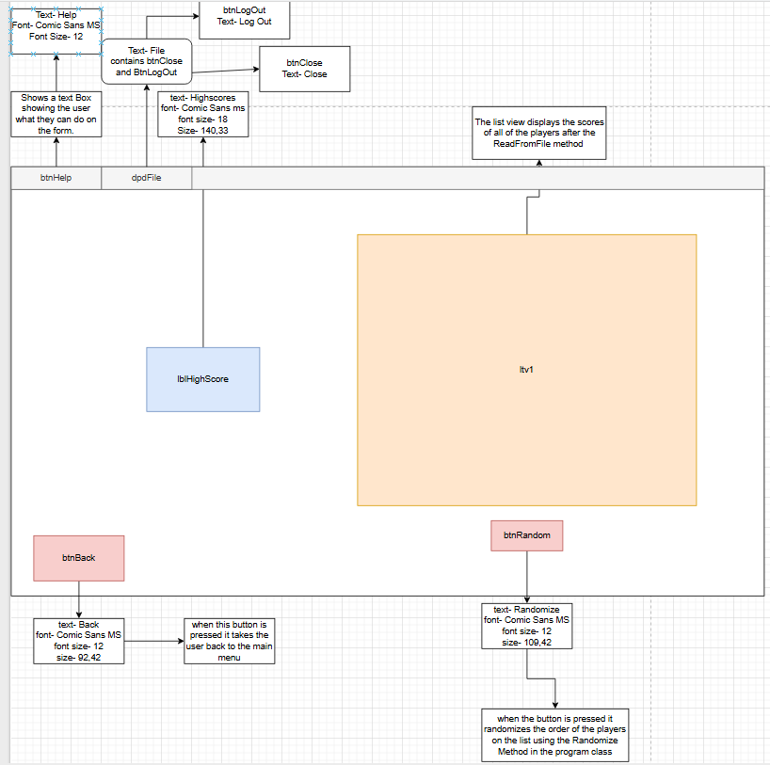

Question 1
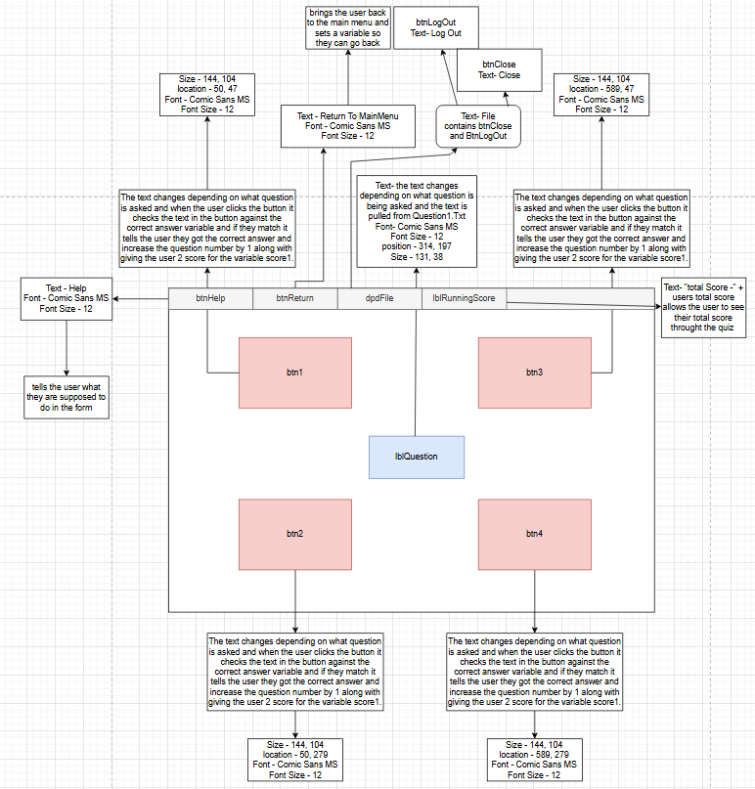
The questions come from Question1.txt

Question 2
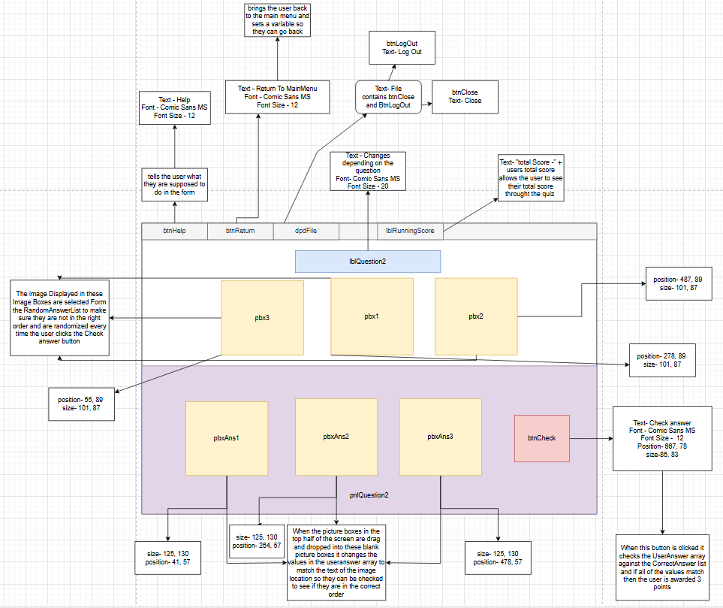
The questions images come from Question2.txt

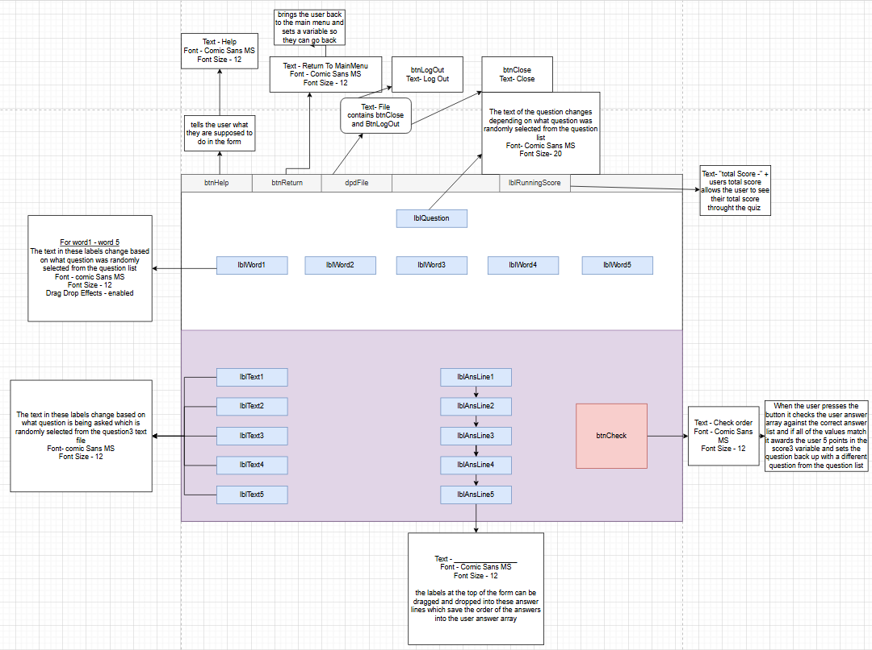
Question 3
The text and questions come from Question3.txt

Question 4
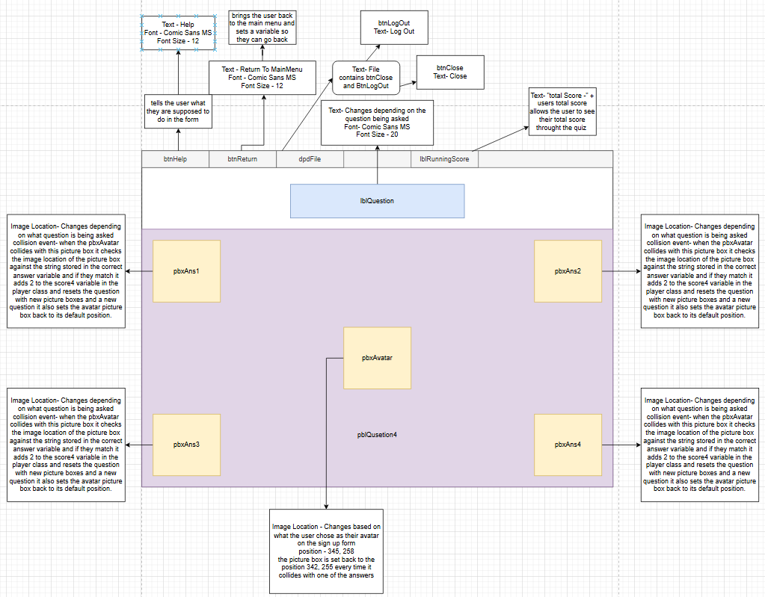

Question 5
The images and questions come from Question4.txt
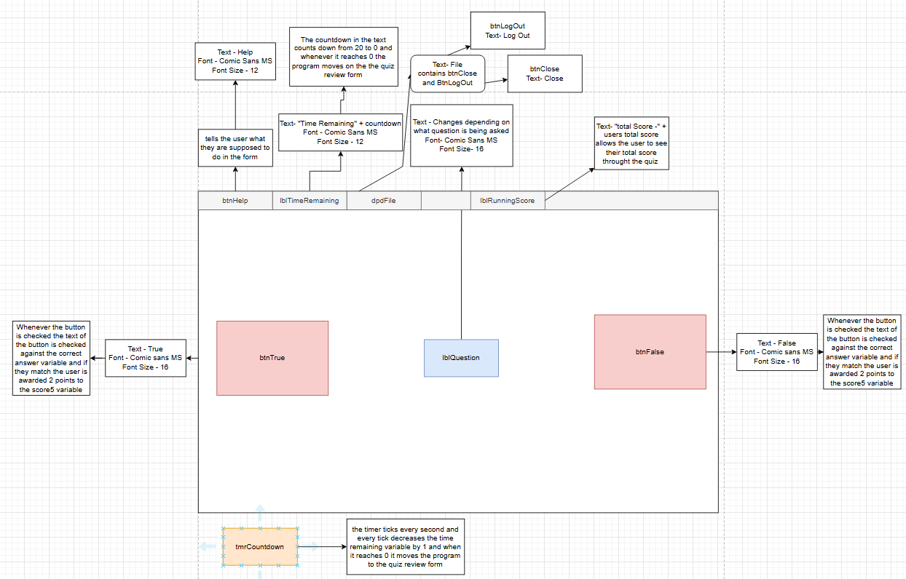
The questions and correct answers come from Question5.txt

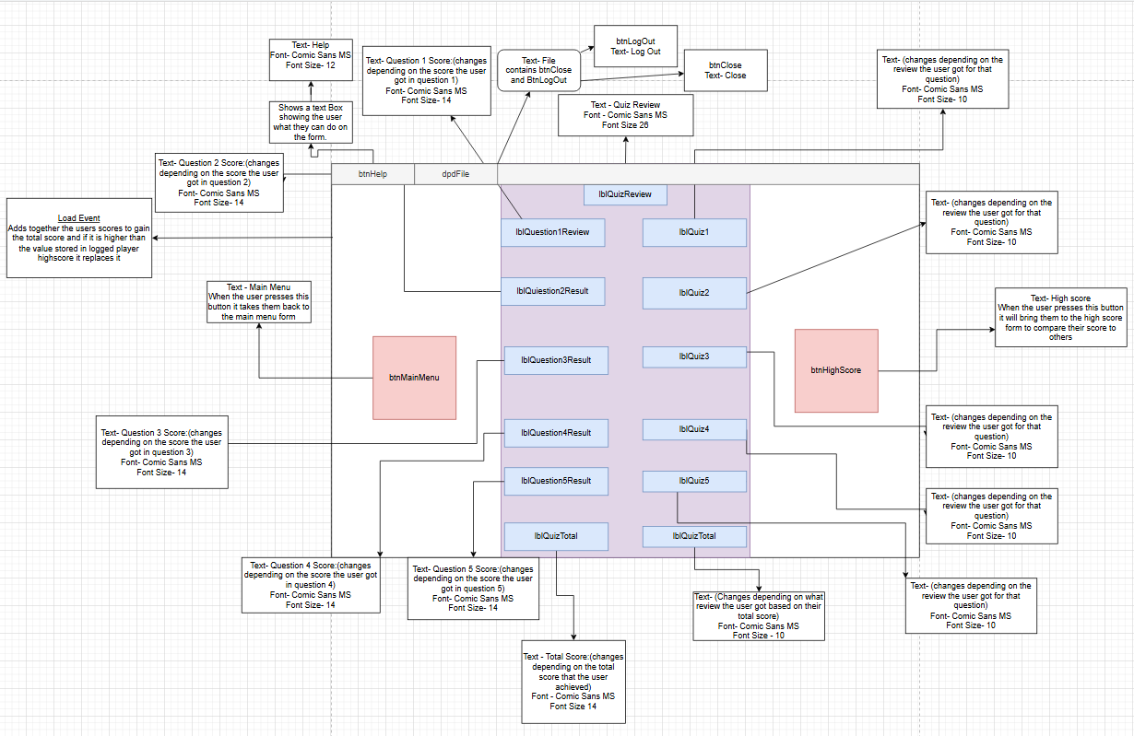
Quiz Review

Class Designs

Question class
The question class allows the creation of a question object that can be made up of a question which hold a string of text to tell the user the question and up to 4 other string variables to hold the answers to the questions the class is public which means the any other form in the program can make use of the class to create questions such as the 5 question forms and it can be used to edit a question making it possible to ask multiple unique questions on a single form
Class identity | Pseudo code | Field description
Public class Question | N/A | N/A

Method identity | Arguments | Pseudo-Code | Method description
Public Question | N/A | N/A | This is an empty constructor that allows an object to be created with no information in it so it can be edited later as all of the variables in the object are blank
Public Question | string questionText  string correctAnswer  string incorrectAnswer1 string incorrectAnswer2 string incorrectAnswer3 string incorrectAnswer4 string incorrectAnswer5 string textline1  string textline2  string textline3  string textline4  string textline5 | _QuestionText equals questionText;  _CorrectAnswer equals correctAnswer;  _incorrectAnswer1 equals incorrectAnswer1;  _incorrectAnswer2 equals incorrectAnswer2;  _incorrectAnswer3 equals incorrectAnswer3;  _incorrectAnswer4 equals incorrectAnswer4;  _incorrectAnswer5 equals incorrectAnswer5;  _textline1 equals textline1;  _textline2 equals textline2;  _textline3 equals textline3;  _textline4 equals textline4;  _textline5 equals textline5; | This constructor creates a full question object with all the information it needs to be asked to the user it includes.  “QuestionText” – the text for the Question the user will be asked.  “CorrectAnswer”- the correct answer to the question.  “incorrectAnswer1-5”- all the other answer given to the user for the question.  “textLine1-5”-used for statements in question 4 where the user has to match words to statements.  However not every question uses all of the components of this object to for those questions the unused variables stay null.  These fields are populated when the user calls the SetUpQuestion method in the question forms which gives the constructor the properties to create a new question object for the user to answer

Property identity | Pseudo code | property description
Public string QuestionText | get;  set; | ‘get’ accessor returns the user’s ‘Question’ value and the ‘set’ accessor allows the ‘Question’ property to be set to a string value
Public string CorrectAnswer | get;  set; | ‘get’ accessor returns the user’s ‘CorrectAnswer’ value and the ‘set’ accessor allows the ‘CorrectAnswer’ property to be set to a string value
Public string IncorrectAnswer1 | get;  set; | ‘get’ accessor returns the user’s ‘IncorrectAnswer1’ value and the ‘set’ accessor allows the ‘IncorrectAnswer1’ property to be set to a string value
Public string IncorrectAnswer2 | get;  set; | ‘get’ accessor returns the user’s ‘IncorrectAnswer2’ value and the ‘set’ accessor allows the ‘IncorrectAnswer2’ property to be set to a string value
Public string IncorrectAnswer3 | get;  set; | ‘get’ accessor returns the user’s ‘IncorrectAnswer3’ value and the ‘set’ accessor allows the ‘IncorrectAnswer3’ property to be set to a string value
Public string IncorrectAnswer4 | get;  set; | ‘get’ accessor returns the user’s ‘IncorrectAnswer4’ value and the ‘set’ accessor allows the ‘IncorrectAnswer4’ property to be set to a string value
Public string IncorrectAnswer5 | get;  set; | ‘get’ accessor returns the user’s ‘IncorrectAnswer5’ value and the ‘set’ accessor allows the ‘IncorrectAnswer5’ property to be set to a string value
Public string TextLine1 | get;  set; | ‘get’ accessor returns the user’s ‘TextLine1’ value and the ‘set’ accessor allows the ‘TextLine1’ property to be set to a string value
Public string TextLine2 | get;  set; | ‘get’ accessor returns the user’s ‘TextLine2’ value and the ‘set’ accessor allows the ‘TextLine2’ property to be set to a string value
Public string TextLine3 | get;  set; | ‘get’ accessor returns the user’s ‘TextLine3’ value and the ‘set’ accessor allows the ‘TextLine3’ property to be set to a string value
Public string TextLine4 | get;  set; | ‘get’ accessor returns the user’s ‘TextLine4’ value and the ‘set’ accessor allows the ‘TextLine4’ property to be set to a string value
Public string TextLine5 | get;  set; | ‘get’ accessor returns the user’s ‘TextLine5’ value and the ‘set’ accessor allows the ‘TextLine5’ property to be set to a string value

Reg exception class
The reg exception class is used whenever the user is creating an account, and an error occurs it allows the program to stop the user from creating a profile that goes against the validation in the code
Method identity | Arguments | Pseudo-Code | Method description
Public Question | string message  base(message) | N/A | This is an empty constructor that only takes in arguments from base classes to allow an error to be created to stop the user creating a user with the wrong details.

Player Class
The player class is used to create a user and store their information such as their user name and their password as well as their score and is marked as public so it can be used by other parts of the program such as the class review form where it needs to display the score that the user got in each question and the review for each score.

Class identity | Pseudo code | Field description
[Serializable]  Public class Player | N/A | Marked as [Serializable] which allows the information to be  Serialized into binary files for later use

Method identity | Arguments | Pseudo-Code | Method description
Public player | string username,  string password  string avatar  int highScore  DateTime dOB  int score1  int score2  int score3  int score4  int score5  int totalscore,  string lastform  string rev1  string rev2  string rev3  string rev4  string rev5  string revTotal | Username equals username;  Password equals password;  Avatar equals avatar;  HighScore equals highScore;  DOB equals dOB;  Score1 equals score1;  Score1 equals score2;  Score1 equals score3;  Score1 equals score4;  Score1 equals score5;  TotalScore equals totalscore;  LastForm equals lastform;  Review1 equals rev1;  Review2 equals rev2;  Review3 equals rev3;  Review4 equals rev4;  Review5 equals rev5;  TotalReview equals revTotal; | This method creates a player that can hold all the information that is need to go through the program such as-  “Username”-stores the users chosen username and saves it so they can log in again at a later date and to be displayed  “Password”- stores the users password so they can log back in  “Avatar”- holds the avatar name so it can be displayed in question 4  “HighScore”- holds the users high score so it can be displayed on leader boards and compared to the users score when they complete the quiz.  “DoB” holds the users date of birth to make sure they are the right age for the program.  “Score1-5”-Holds the score that the user got on each question so it can be added up to get the total score and to be displayed on the quiz review.  “TotalScore”-Holds the users total score so it can be compared to the users high score and displayed on the quiz review form  “LastForm”-holds a string value for the last question form the user was on so they can go between the main menu and the questions at any time.  “Review1-5”- Holds the text for the review the user received for each of their questions depending on how they did on the question.  “TotalReview”- Holds a value for the Review of how the user did overall in the form and is set in the load event of the quiz review form.
Public Player | N/A | N/A | Creates an empty player object that values can be set to at another time as at the start all of the values hold their null values.

Property identity | Pseudo code | property description
Public string Username | get;  set; | ‘get’ accessor returns the user’s ‘Username’ value and the ‘set’ accessor allows the ‘Username’ property to be set to a string value
Public string Password | get;  set; | ‘get’ accessor returns the user’s ‘Password’ value and the ‘set’ accessor allows the ‘Password’ property to be set to a string value
Public string Avatar | get;  set; | ‘get’ accessor returns the user’s ‘Avatar’ value and the ‘set’ accessor allows the ‘Avatar’ property to be set to a string value
Public DateTime DOB | get;  set; | ‘get’ accessor returns the user’s ‘DOB’ value and the ‘set’ accessor allows the ‘DOB’ property to be set to a DateTime value
Public int Score1 | get;  set; | ‘get’ accessor returns the user’s ‘Score1’ value and the ‘set’ accessor allows the ‘Score1’ property to be set to an int value
Public int Score2 | get;  set; | ‘get’ accessor returns the user’s ‘Score2’ value and the ‘set’ accessor allows the ‘Score2’ property to be set to an int value
Public int Score3 | get;  set; | ‘get’ accessor returns the user’s ‘Score3’ value and the ‘set’ accessor allows the ‘Score3’ property to be set to an int value
Public int Score4 | get;  set; | ‘get’ accessor returns the user’s ‘Score4’ value and the ‘set’ accessor allows the ‘Score4’ property to be set to an int value
Public int Score5 | get;  set; | ‘get’ accessor returns the user’s ‘Score5’ value and the ‘set’ accessor allows the ‘Score5’ property to be set to an int value
Public int TotalScore | get;  set; | ‘get’ accessor returns the user’s ‘TotalScore’ value and the ‘set’ accessor allows the ‘TotalScore’ property to be set to an int value
Public string LastForm | get;  set; | ‘get’ accessor returns the user’s ‘LastForm’ value and the ‘set’ accessor allows the ‘LastForm’ property to be set to a string value
Public string Review1 | get;  set; | ‘get’ accessor returns the user’s ‘Review1’ value and the ‘set’ accessor allows the ‘Review1’ property to be set to a string value
Public string Review2 | get;  set; | ‘get’ accessor returns the user’s ‘Review2’ value and the ‘set’ accessor allows the ‘Review2’ property to be set to a string value
Public string Review3 | get;  set; | ‘get’ accessor returns the user’s ‘Review3’ value and the ‘set’ accessor allows the ‘Review3’ property to be set to a string value
Public string Review4 | get;  set; | ‘get’ accessor returns the user’s ‘Review4’ value and the ‘set’ accessor allows the ‘Review4’ property to be set to a string value
Public string Review5 | get;  set; | ‘get’ accessor returns the user’s ‘Review5’ value and the ‘set’ accessor allows the ‘Review5’ property to be set to a string value
Public string TotalReview | get;  set; | ‘get’ accessor returns the user’s ‘TotalReview’ value and the ‘set’ accessor allows the ‘TotalReview’ property to be set to a string value

Program Class
The program class is public allowing the program to utilise the methods in the program class throughout the program without having to remake them on every form which makes the code more readable and easier to fix errors with
Method identity | Arguments | Pseudo-Code | Method description
public static void RandomizeList<T> | IList<T> list | The program first creates a new array called random.  Then a for loop which loops once for every item in the list  The loop changes around the values in the list once for each item in the list to make the list completely random | This method allows the program to randomize the list view in the high score form and it randomizes the order of the questions in the text files when a quiz form opens
public static void WriteToFile | List<Player> playerList | The program creates a new array object.  It then opens the playerlist.bin file and adds the data to the file in binary format.  It then catches any exceptions and creates an error message | This method allows the program to write information to the player list binary file which is used to store information about the players it is made in the programming class because it is called multiple times throughout the program such as In the sign up form and in the quiz review form where it is used to update the information with the players new high score.
public static List<Player> ReadFromFile | List<Player> playerList | The program creates a new array object.  Then the program opens and reads the information from the playerlist.bin file and closes it.  The program will also catch any exception and make the console output an error message.  If an error doesn’t occur the program then returns the information that it read from the file | This method allows the program to read the information from the player list binary file to access the information inside this is used in the log in form to check whether or not the details the user enters matches that of an existing user and in the high score form to get the information that is required to populate the list view.
static void Main() | N/A | This causes the program to open and dictates the form that the program opens on | This method is what allows the program to run and selects what form the program opens on
public static void SortList | List<Player> obj | creates a new array called player.  it then starts a for loop the goes through each player object.  the objects then go through a bubble sort to place them in the correct order from highest score to lowest high score.  the program then returns the list | This method is used on the main menu form to allow the list view to sort the players in order of their high score by using a bubble sort

Testing
Test No. | Form |  | Test Description |  |  | User Req. | Test Data |  | Expected Outcome |  |  | Pass/Fail  ✔ / ✖ |  | Evidence
1 | frmSplash |  | The program must start on the splash screen |  |  | UR1 | Start the program |  | The splash screen will appear |  |  | ✔
2 | FrmSplash |  | The user can skip the splash screen by pressing the enter key |  |  | UR3 | Press the enter key while on frmSplash |  |  |  |  | ✔
3 | frmSplash |  | The program must move to the next form after the timer ticks |  |  | UR1 | TmrLoading |  | The Sign-up form will open and the splash screen will close |  |  | ✔
4 | frmSignUp |  | The user must be able to enter in a password and a username when creating a new account  (valid) |  |  | UR2 | tbxUsername  tbxPassword |  | The user will be able to type in a username and password |  |  | ✔
5 | frmSignUp |  | A message box will appear if the user enters in a password or username that doesn’t pass the verification  (invalid) |  |  | UR2  UR15 | tbxUsername  tbxPassword |  | A message box will appear telling the user what is wrong with their username |  |  | ✖ |  | See corrective action -CA1
6 | frmSignUp |  | The user will not be able to leave the username and password box empty  (null) |  |  | UR2 | tbxUsername  tbxPassword |  | A message box will appear telling the user that they need to enter a username or password |  |  | ✔
7 | frmSignUp |  | The username and password can be up to 19 letters or as little as 9 letters (extreme) |  |  | UR2 | tbxUsername  tbxPassword |  | The user should be able to create their account even though the username and password are on the boundary of what is accepted |  |  | ✔
8 | frmSignUp |  | The user will be able to enter in their date of birth when creating an account  (Valid) |  |  | UR2 | dtpDOB |  | The user will be able to create an account and will be taken to the next form |  |  | ✔
9 | frmSignUp |  | The user won’t be able to enter a date of birth past the year 2011 or before the year 2000 |  |  | UR2  UR15 | dtpDOB |  | A message box will appear telling the user that they are to young or old to be doing the quiz depending on what year thy entered |  |  | ✔
10 | frmSignUp |  | The user should be able to click on an avatar and have it become their avatar for the rest of the program |  |  | UR2 | pbxAvatar1  pbxAvatar2  pbxAvatar3  pbxAvatar4  pbxChosenAvatar |  | When the user selects an avatar, it changes the image in the Chosen avatar picture box to reflect their choice. |  |  | ✔
11 | frmSignUp |  | When creating the user, the chosen avatar should be saved to the user |  |  | UR2 | pbxChosenAvatar |  | The chosen avatar is saved into the avatar variable so it can be used later in the program |  |  | ✔
12 | frmSignUp |  | When trying to create a new profile if the user doesn’t select an avatar, they shouldn’t be able to make it  (Null) |  |  | UR2  UR15 | pbxChosenAvatar |  | A message box will appear telling the user that they need to select an avatar |  |  | ✖ |  | Go to corrective action – CA2
13 | FrmSignUp |  | When the user presses the help button in the menu strip a message box should appear telling the user what they are supposed to do on the form |  |  | UR4 | btnHelp |  | A message box will appear on the screen telling the user what they are supposed to do on the form to progress though the program |  |  | ✔
14 | frmSignUp |  | The User should be able to go right to the login screen if they have already made an account |  |  | UR2 | btnLogIn |  | The user will be taken to the Log in screen without having to create an account |  |  | ✔
15 | frmSignUp |  | The user should be able to create an account by pressing the enter button  (Valid) |  |  | UR2 | btnEnter |  | If the information entered by the user fits the boundaries of the program the details will be written to a binary file |  |  | ✔
16 | frmSignUp |  | The user shouldn’t be able to create an account if their account doesn’t fit the criteria(invalid) |  |  | UR1  UR2 | btnEnter |  | If the information entered by the user is invalid, then a message box will appear telling the user what is wrong with what they entered |  |  | ✔
17 | frmSignUp |  | The user can’t create an account if they don’t enter in any information (Null) |  |  | UR1  UR2 | btnEnter |  | A message box will appear telling the user that they have to enter in information to create an account |  |  | ✔
18 | frmSignUp |  | When the user creates an account, the details will be saved into the logged user variable for later use |  |  | UR1  UR2 | btnEnter |  | The details that the user entered will be added to the logged user variable. |  |  | ✔
19 | frmLogInScreen |  | The user can log in if they enter the correct username and password  (valid) |  |  | UR5 | btnEnter |  | A message box will appear telling the user that the log in was successful and they will be taken to the Main Menu form |  |  | ✔
20 | frmLoginScreen |  | The user can’t log in if they enter the incorrect username and password  (invalid) |  |  | UR5 | btnEnter |  | A message box will appear telling the user they entered the wrong username or password, and it resets the text inside of the username and password text boxes |  |  | ✔
21 | FrmLoginScreen |  | The user can’t log in if they don’t enter a username or password |  |  | UR5 | btnEnter |  | A message box will appear telling the user that a username or password wasn’t entered |  |  | ✖ |  | Go to corrective action – CA3
22 | frmLoginScreen |  | The user can click the Sign-up button to go back to the sign up form and create an account if they don’t have one |  |  | UR6 | btnSignUp |  | The user will be taken to the Sign-up form again so they can create an account |  |  | ✔
23 | frmLoginScreen |  | The user can click the help button in the menu strip to get told what they have to do on that form |  |  | UR4 | btnHelp |  | A message box will appear telling the user what they have to do on the Log in form |  |  | ✔
24 | FrmLoginScreen |  | If the user has just created an account, the information saved to the logged user will be auto inputted allowing the user to skip entering their details |  |  | UR2  UR5 | Open frmLogin after creating an account |  | The user and password will be filled in automatically |  |  | ✔
25 | frmLoginScreen |  | The user’s password should be hidden when they are entering it |  |  | UR22 | Start to enter a password |  | The password will be displayed as stars stopping other from seeing it |  |  | ✔
26 | frmMainMenu |  | The correct information will be shown to the user in the main menu |  |  | UR7 | pbxAvatar  lblUsername |  | The avatar and username the user selected on the sign-up form will be displayed |  |  | ✔
27 | frmMainMenu |  | The user can go to the quiz review form from the main menu  (valid) |  |  | UR1 | btnQuizReview |  | The user will be taken to the Quiz review form |  |  | ✔
28 | frmMainMenu |  | The user can’t go to the quiz review before the complete the quiz(invalid) |  |  | UR1 | btnQuizReview |  | A message box will appear telling the user that they haven’t completed the quiz yet |  |  | ✔
29 | frmMainMenu |  | The user can start the quiz from the main menu by clicking the quiz button |  |  | UR1 | btnQuiz |  | The user will be taken to the first question of the quiz |  |  | ✔
30 | frmMainMenu |  | The user can go to the high scores form at anytime |  |  | UR1 | btnHighScore |  | The user will be taken to the High Score form |  |  | ✔
31 | frmMainMenu |  | The user will be able to log out at the Main Menu |  |  | UR8 | btnLogOut |  | The user will be taken back to the sign-up form and the logged player variable will be cleared |  |  | ✔
32 | frmMainMenu |  | The user will be able to return to the last question they were on in the quiz  (valid) |  |  | UR6  UR21 | btnReturn |  | The user will be taken back to the last question they were on in the quiz |  |  | ✔
33 | frmMainMenu |  | The user won’t be able to return to the quiz if the quiz hasn’t been started prior  (invalid) |  |  | UR1 | btnReturn |  | The user will be told that they haven’t started the quiz yet and will stay on the main menu |  |  | ✔
34 | frmMainMenu |  | The list view will show the users with the top ten scores in order |  |  | UR9 | Open the main menu form |  | The user will be able to compare their scores with others as the list will show the top ten scores |  |  | ✔
35 | FrmMainMenu |  | The user can access help by pressing the help button in the menu strip |  |  | UR4 | Press btnHelp |  | A message box will appear telling the user what they have to do in order to progress in the program |  |  | ✔
36 | frmHighScore |  | The list view will show all the users who have completed the quiz |  |  | UR9 | Open the high score form |  | The list view will show all of the players who have competed the quiz in a random order |  |  | ✔
37 | frmHighScore |  | The user should be able to randomize the list view by pressing the randomize button |  |  | UR9  UR10 | Press the randomize button |  | The list view will be cleared and repopulated in a random order when the button is pressed |  |  | ✔
38 | frmHighScore |  | The user should be able to go back to the main menu from the high score form |  |  | UR1 | Press the back button |  | The user should be taken back to the main menu form |  |  | ✔
39 | frmHighSore |  | The user can access help by pressing the help button in the menu strip |  |  | UR4 | Press btnHelp |  | A message box will appear telling the user what they can do on their current form |  |  | ✔
40 | frmQuestion1 |  | The user gets a random question when they open the form |  |  | UR1  UR11 | Open the Question1 form |  | When the form is opened a random question will appear in the centre of the screen and the buttons in the corners will have random answers to the question |  |  | ✔
41 | frmQuestion1 |  | The user can click on one of the corner buttons to advance the quiz  (valid) |  |  | UR1  UR11  UR16 | Click the answer button which matches the correct answer to the question |  | A message box will appear telling the user that they got the question right and they will gain 2 points in the variable Score1 |  |  | ✔
42 | frmQuestion1 |  | The user can click on one of the corner buttons to answer the question  (invalid) |  |  | UR1  UR11  UR16 | Click one of buttons which doesn’t match the correct answer |  | A message box will appear telling the user that they got the question wrong, and the question will reset |  |  | ✔
43 | frmQuestion1 |  | The user will be taken to the next question if the current question variable is equal to 5  (valid) |  |  | UR1 | Answer 5 questions on the form |  | The user will be taken to the next question in the quiz and their score for question 1 will be added to their total score |  |  | ✔
44 | frmQuestion1 |  | The user won’t be taken to the next question if they haven’t answered 5 questions yet  (invalid) |  |  | UR1 | Answer 3 questions on the form |  | The Question will be reset again until the current question is equal to 5 |  |  | ✔
45 | frmQuestion1 |  | The user can’t be asked the same question 2 times in a row |  |  | UR11 | Answer multiple questions to see if the same one appears twice in a row |  | No question will appear twice in a row |  |  | ✖ |  | Go to corrective action -CA4
46 | frmQuestion1 |  | The user can save their place and go back to the main menu from question 1 |  |  | UR12 | Press the Back to main menu button on the menu strip |  | The user will be taken back to the main menu and the question they are on will be saved |  |  | ✔
47 | frmQuestion1 |  | The program will display a message depending on how well the user preformed in the question |  |  | UR20 | Answer 5 question |  | A message box will appear telling the user how they performed in the question and then the message is saved in QuizReview1 for the quiz review form |  |  | ✔
48 | frmQuestion1 |  | The user can access help by pressing the help button in the menu strip |  |  | UR4 | Press btnHelp |  | A message box will appear telling the user what they have to do in order to progress in the program |  |  | ✔
49 | frmQuestion2 |  | The user can drag the picture boxes |  |  | UR1  UR13 | Click on one of the picture boxes and drag the mouse to somewhere else on the screen |  | The picture box will be moved to wherever the mouse is dragged and will be taken back to its original position when they unclick |  |  | ✔
50 | frmQuestion2 |  | The user can drop the picture boxes into the answer picture boxes |  |  | UR1  UR13 | Drag one of the picture boxes over one of the boxes at the bottom of the screen and unclick |  | The image in the answer picture box gets changed to match the dragged image |  |  | ✔
51 | frmQuestion2 |  | The image the user drops into the picture box will be saved |  |  | UR1  UR13 | Drop an image into one of the answer picture boxes |  | The name of the image in the picture box will be saved to a spot in the user answer array |  |  | ✔
52 | frmQuestion2 |  | The Question will reset after the user clicks the check answer button |  |  | UR1  UR16 | Press the check answer button |  | The images in the picture boxes and the question will change |  |  | ✔
53 | frmQuestion2 |  | The user should be able to check their answers to question 2  (Valid) |  |  | UR1  UR13 | Press the check answer button |  | A message box will appear telling the user that they got the order correct and the user will get 3 score towards their score 2 and total score variables |  |  | ✔
54 | frmQuestion2 |  | The user should be able to check their answers to question 2 |  |  | UR1  UR13 | Press the check answer button with the wrong answer |  | A message box will appear telling the user that they got the order wrong, and the question will reset |  |  | ✔
55 | frmQuestion2 |  | The user should be able to check their answer to question 2  (null) |  |  | UR1  UR13 | Press the check answer button  Without answering the question |  | A message box will appear telling the user that they haven’t put the images in an order and the question will reset |  |  | ✔
56 | frmQuestion2 |  | The user should be able to go back to the main menu from question 2 |  |  | UR12 | Press the Back to main menu button on the menu strip |  | The user will be taken back to the main menu and their spot in the quiz will be saved so they can go back to that point |  |  | ✔
57 | frmQuestion2 |  | The user should receive feedback on how they performed in question 2 after they complete it |  |  | UR20 | Answer 5 questions |  | Depending on what score they achieved in question 2 a message box will appear telling them how they did |  |  | ✖ |  | Go to corrective action -CA5
58 | frmQuestion2 |  | The user should be taken to the next question once they answer 5 questions |  |  | UR1 | Answer 5 questions |  | The user will be taken to the question 3 from |  |  | ✔
59 | frmQuestion2 |  | The user can access help by pressing the help button in the menu strip |  |  | UR4 | Press btnHelp |  | A message box will appear telling the user what they have to do in order to progress in the program |  |  | ✔
60 | frmquestion3 |  | The user should be able to drag the text |  |  | UR13 | Click on the text and move the mouse |  | The text will be moved to the position of the mouse on the screen |  |  | ✔
61 | frmQuesiton3 |  | The user should be able to drop the text into the answer line |  |  | UR13 | Drag the text and unclick when the text is above the answer line |  | The text will be placed onto the answer line |  |  | ✔
62 | frmQuestion3 |  | The user should be able to drop the text into the answer line and have it saved into the user answer array |  |  | UR13 | Drag and drop the text onto the answer line |  | The text will be placed on the answer line and the text will be saved into the user answer array |  |  | ✔
63 | Frmquestion3 |  | The user should be able to replace the word on the answer line if they put the wrong answer in |  |  | UR13 | Drag and drop the text onto the answer line when there is already another word there |  | The text on the line will be replaced by the new word |  |  | ✔
64 | frmQuestion3 |  | The user should be able to check their answer by pressing the check answer button  (valid) |  |  | UR1 | Press the Check answer button in the bottom right of the form with the correct order entered |  | A message box will appear telling the user that they got the order correct and 5 points will be added to the score 3 and total score variables |  |  | ✔
65 | frmQuestion3 |  | The user should be able to check their answer by clicking the check answer button(invalid) |  |  | UR1 | Press the check answer button with the incorrect order |  | A message box will appear telling the user that they got the order incorrect and they won’t gain any points |  |  | ✔
66 | frmQuestion3 |  | The question will reset when the check answer button is clicked |  |  | UR1  UR16 | Press the check answer button |  | The question and the answers will change to a different one from the Question3.txt file |  |  | ✖ |  | See corrective action -CA6
67 | frmQuestion3 |  | The user will be taken to the next form after they answer 5 questions |  |  | UR1 | Answer 5 questions |  | the user will be taken to the next question |  |  | ✔
68 | frmQuestion3 |  | The program will display a message depending on how well the user preformed in the question |  |  | UR20 | Answer 5 question |  | A message box will appear telling the user how they performed in the question and then the message is saved in QuizReview3 for the quiz review form |  |  | ✔
69 | frmQuestion3 |  | The user can go back to the main menu from question 3 and it will reset the question |  |  | UR12 | Click the return to main menu on the menu strip |  | The user will be taken back to the main menu and the current question, and the question 3 score will be reset |  |  | ✔
70 | frmQuestion3 |  | The user can access help by pressing the help button in the menu strip |  |  | UR4 | Press btnHelp |  | A message box will appear telling the user what they have to do in order to progress in the program |  |  | ✔
71 | frmQuestion4 |  | The user’s avatar will appear in the centre picture box |  |  | UR7 | Open the question 4 form |  | The picture box in the centre of the screen will have its image location changed to the location of the Users chosen avatar |  |  | ✔
72 | frmQuestion4 |  | The user can Move their avatar with the arrow keys |  |  | UR3 | Press the arrow keys when you get into frmQuestion4 |  | The Avatar will move in the direction corresponding to the arrow keys |  |  | ✔
73 | frmQuestion4 |  | The user can move the avatar to the position of one of the picture boxes to answer the question  (valid) |  |  | UR3 | Press the arrow keys to move the avatar to the Picture box with one of the answers |  | The Avatar will be reset to the original position and a message box will appear telling the user that they got the question correct |  |  | ✔
74 | frmQuestion4 |  | The user can move the avatar to the position of one of the picture boxes to answer the question(invalid) |  |  | UR3 | Press the arrow keys to move the avatar to one of the answers |  | The avatar will be reset to its original position and a message box will appear telling the user that they got the question incorrect c |  |  | ✔
75 | frmQuestion4 |  | The user can go back to the main menu from question 4 |  |  | UR12 | Press the return to main menu button on the menu strip |  | The user will be taken back to the main menu and the form that the user was last on will be saved in the last form variable so they can return to it later |  |  | ✔
76 | frmQuestion4 |  | The user will be taken to the next form when they have answered 5 questions |  |  | UR1 | Answer 5 questions |  | The user will be taken to question 5 |  |  | ✔
77 | frmQuestion4 |  | The program will display a message depending on how well the user preformed in the question |  |  | UR20 | Answer 5 question |  | A message box will appear telling the user how they performed in the question and then the message is saved in QuizReview4 for the quiz review form |  |  | ✔
78 | frmQuestion4 |  | When the user answers a question, the question will reset to another question on the list |  |  | UR1  UR14  UR16 | Answer a question |  | The text for the question and the picture boxes will change to match the new random question |  |  | ✔
79 | frmQuestion4 |  | The user can access help by pressing the help button in the menu strip |  |  | UR4 | Press btnHelp |  | A message box will appear telling the user what they have to do in order to progress in the program |  |  | ✔
80 | frmQuestion5 |  | The question will be set up when the user enters the form |  |  | UR1  UR14 | Enter the Question 5 form |  | The user will be given a random question from the Question5.txt file when the form is opened |  |  | ✔
81 | frmQuestion5 |  | The user will be able to answer the questions using the true and false buttons(invalid) |  |  | UR1  UR16 | Press true or false button |  | No score will be added to the score 5 variable and total score |  |  | ✔
82 | frmQuestion5 |  | The user will be able to answer the questions using the true and false buttons(valid) |  |  | UR1  UR16 | Press the true or false button |  | 2 score will be added to the score 5 and total score variable |  |  | ✔
83 | frmQuestion5 |  | The countdown will change depending on how the user answers the question(valid) |  |  | UR1  UR17 | Press the true or false button |  | 1 seconds will be added to the countdown |  |  | ✔
84 | frmQuestion5 |  | The countdown will change depending on how the user answers the question(invalid) |  |  | UR1  UR17 | Press the true or false button |  | 3 second will be removed from the countdown |  |  | ✔
85 | frmQuestion5 |  | A countdown will start when the user enters the form |  |  | UR1  Ur17 | Enter the Question 5 form |  | The countdown on the menu strip will start to count down to 0 |  |  | ✔
86 | frmQuestion5 |  | The user will be taken to the quiz review form when the timer reaches 0 |  |  | UR1 | Wait for the countdown to reach 0 |  | The user will be taken to the quiz review form, and the timer will stop. The users score for question 5 will also be added to the total score. |  |  | ✖ |  | See corrective action -CA7
87 | frmQuestion5 |  | The user can access help by pressing the help button on the menu strip |  |  | UR4 | Click the Help button on the menu strip |  | A message box will appear telling the user what they are supposed to do on that form |  |  | ✔
88 | frmQuestion5 |  | The user will be taken to the next form early if they answer all the questions before the time runs out |  |  | UR1 | Answer 15 questions |  | A message box will appear telling the user that they answered all the questions before the time ran out and they will be taken to the quiz review form |  |  | ✖ |  | See corrective action -CA8
89 | frmQuestion5 |  | The program will display a message depending on how well the user preformed in the question |  |  | UR20 | Answer 15 question or let the timer reach 0 |  | A message box will appear telling the user how they performed in the question and then the message is saved in QuizReview5 for the quiz review form |  |  | ✖ |  | See corrective action -CA9
90 | frmQuestion5 |  | The user should be able to see their total score from any of the questions |  |  | UR24 | Open frmQuestion5 |  | On the menu strip there will be a label that contains the total score |  |  | ✔
91 | frmQuestion5 |  | When a user answers a question on question 5 their total score in the menu strip should be updated |  |  | UR24 | Answer a question correctly |  | The total score in the label will be increased by 2 points |  |  | ✔
92 | frmQuizReview |  | When the user enters the form if the user achieved a new high score a message box will appear |  |  | UR2  UR18 | Enter the quiz review form |  | A message box will appear telling they achieved a new high score of “” when they enter the form |  |  | ✔
93 | frmQuizReview |  | The user can go to the high score form from the quiz review form |  |  | UR1 | Click btnHighScore |  | The user will be taken to the high score form |  |  | ✔
94 | frmQuizReview |  | The user can go back to the main menu from the Quiz Review after thy finish the quiz |  |  | UR1  UR12 | Click btnMainMenu |  | The user will be taken back to the main menu form |  |  | ✔
95 | frmQuizReview |  | When the user enters the Quiz review form different messages appear depending on how the user preformed in the different parts of the quiz |  |  | UR1  UR19 | Enter  frmQuizReview |  | Text will appear below the different scores that the user got throughout the quiz depending on how the user did e.g. well done you got the highest boundary |  |  | ✖ |  | See corrective action -CA10
96 | frmQuizReview |  | When the user gets a new high score, the program will write the new high score to the binary file |  |  | UR1  UR7  UR9 | Get a new High score |  | The new high score overwrites the user old high score in the bin file |  |  | ✔
97 | frmQuizReview |  | When the user enters the quiz review form it will use their total score to give a statement depending on how well they did. |  |  | UR1 | Enter the high score form |  | The label at the bottom of the form will display how the user did and next to it another label will display the review of the users score. |  |  | ✔
Improvements
Test No. |  | Form |  | Test Description | User Req. |  |  | Test Data |  | Expected Outcome | Pass/Fail  ✔ / ✖ |  | Evidence
98 |  | frmMainMenu |  | The user should be able to log out using the menu strip | UR8 |  |  | Open the file drop down menu and click the log out button |  | The user will be taken to the sign-up form and the logged user data will be set to null | ✔
99 |  | frmMainMenu |  | The user should be able to close the program through the menu strip | UR23 |  |  | Open the file drop down menu and click the close button |  | The program will close | ✔
100 |  | frmQuestion5 |  | The timer should stop when the user clicks the help button | UR4 |  |  | Click btnHelp |  | The timer will stop, and the help message will appear | ✔

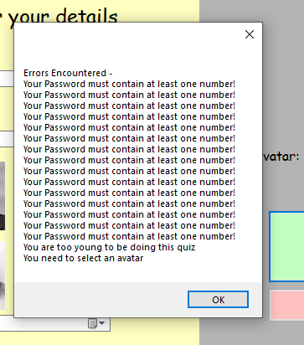
Corrective Action
CA1-Whenever an error occurred when a user was being created the error message would appear multiple times. When I checked the code, it found out that the foreach loop that I was using was looping through more information that it should have causing the error message to appear once for every user in the player list binary file so I reduced the information it looped through, and the error was fixed
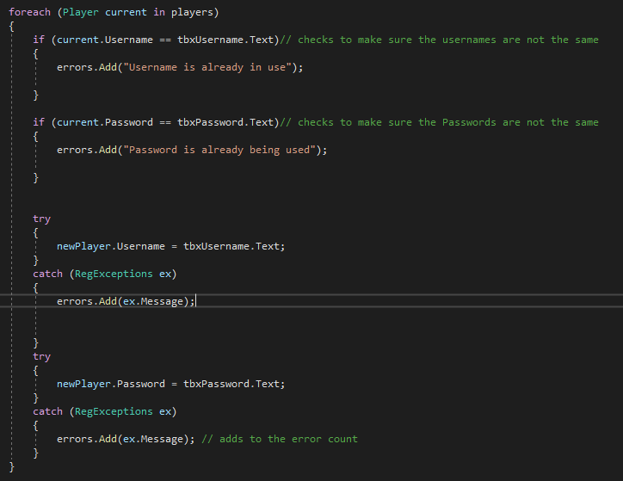
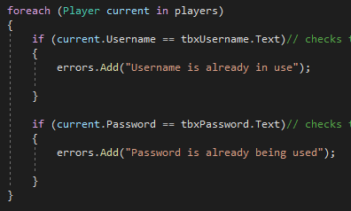
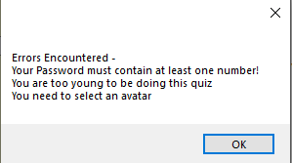
To fix the error I changed the position of the end of the for each loop to make sure it only went through the information it needed to and didn’t add unnecessary errors so that multiple of the same message didn’t appear
When I made the change, I checked the code again and entered the same information that caused the error to occur and when I tried the create the user only one of each error type occurred
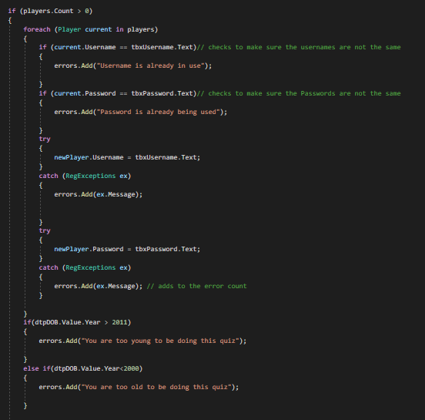
CA2- When I clicked enter it allowed the user through to the login screen even though they haven’t selected an avatar. I checked the code and found out that there was no verification for the avatar so after I added a simple if statement that would cause an error if no avatar was selected
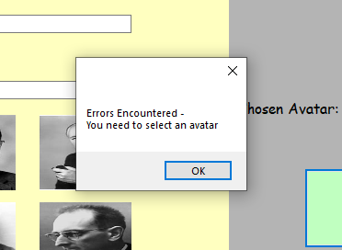
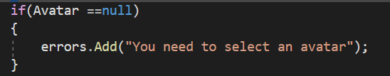
After the validation for the Avatar was added I ran the code again and the program wouldn’t allow a user to be created that didn’t have an avatar to avoid issues in later forms such as the main menu where the avatar is displayed or in question 4 where the avatar is used to answer the question
Now when someone tries to create a user without an avatar this error message will appear and reset the form to its original state.
CA3-When the user would try to log in without a password or username it would give the incorrect error message telling them that they entered the wrong details instead on not entering details at all

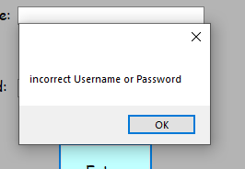
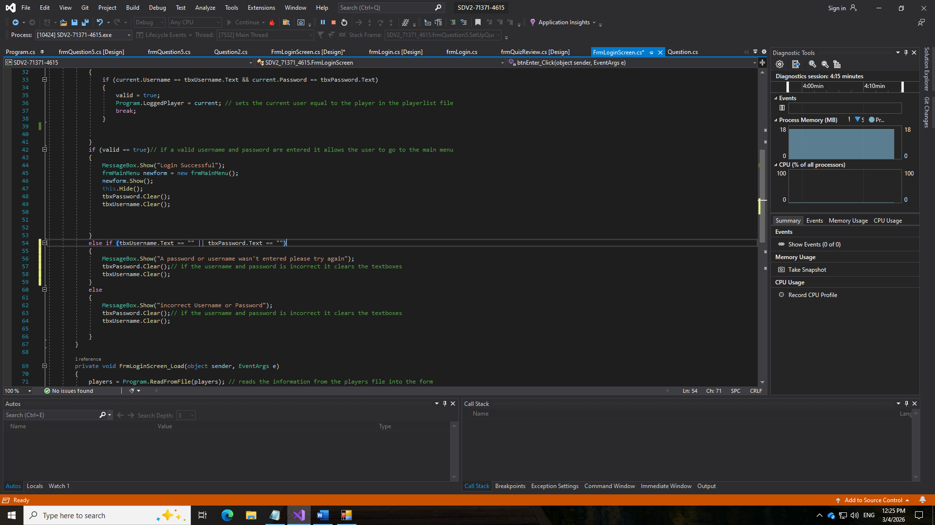
After adding this code, I ran the program again to see if it would fix the problem and when I tried to log in using no password or username it gave me a different error message that before saying “A password or username wasn’t entered please try again” and it didn’t allow the user to get to the main menu.

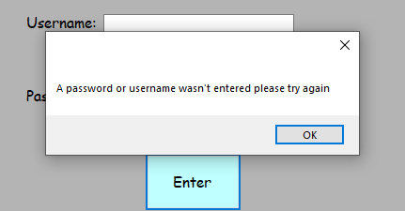
After seeing the error, I checked the code and found that I forgot to add validation to check if the textboxes for the password or username were empty, so I added an else if statement after the check to see if the details were correct to check if a password or username was entered.

CA4-Whenever the user was doing any of the questions sometimes the same question would appear twice in a row giving the user a good opportunity to score more points however this isn’t intentional and could make the quiz pointless as the user isn’t learning anything by answer the same question twice in a row, so I checked the code to see If there was a way to stop this from happening
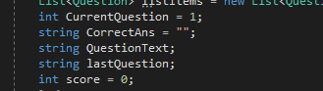
First, I created a new variable called LastQuestion which would store the text of the last question the user was asked and would change each time the SetUpQuestion variable was called which allowed it to work throughout the question and not only for the first one
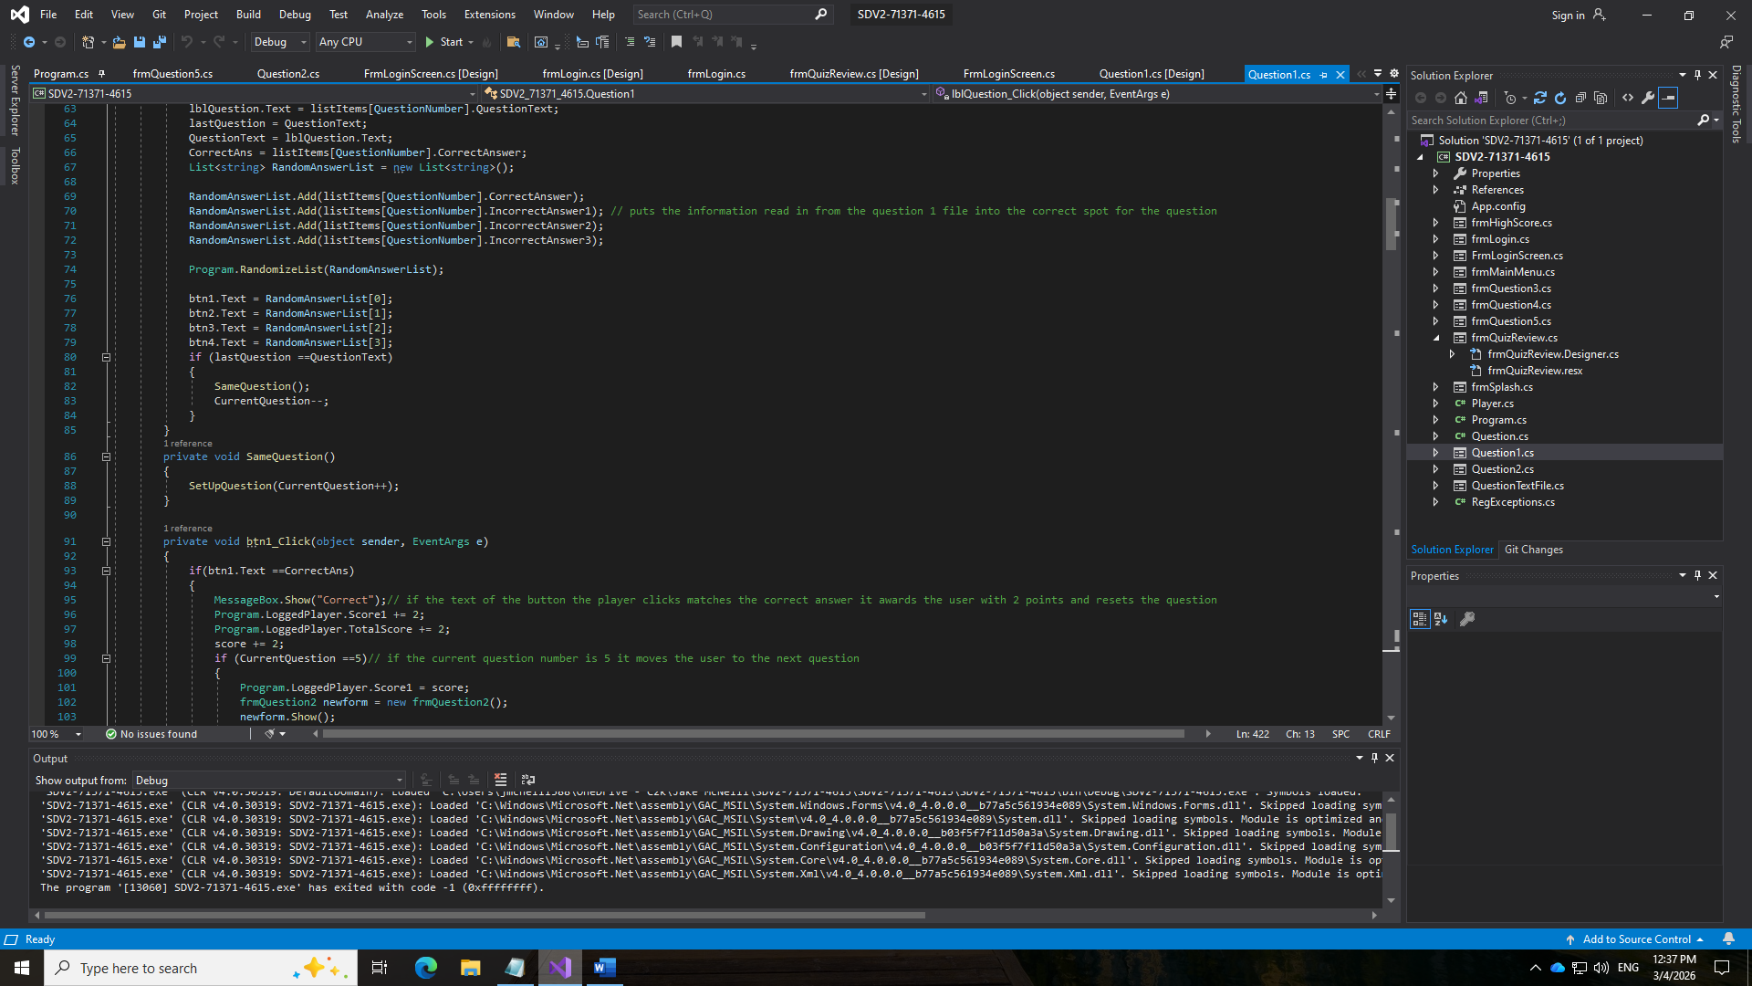
Then in the SetUpQuestion I added validation to make sure the new question wasn’t the same as the old question using an if statement to check the lastQuestion variable against the QuestionText and if they matched then the SameQuestion method would be called to reset the question adding 1 to the current question variable so to cancel this out I made the if statement remove 1 from the currentQuestion variable

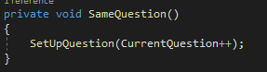
After creating the new variable, I created a new method that I could call which cause the question to reset with a new question

CA5-Whenever the user completed question 2 in the quiz no message box would appear to tell the user how they did, and nothing would be saved to the review2 variable so nothing would show in the quiz review.
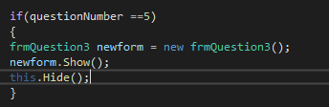
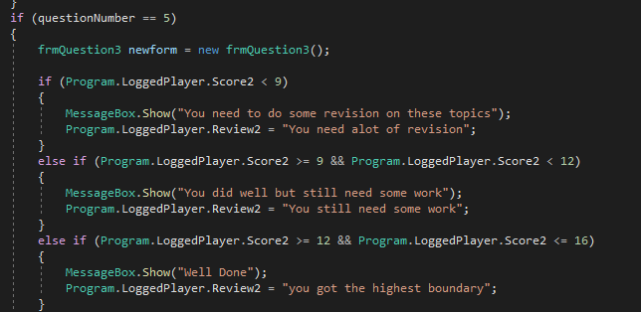
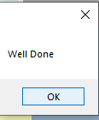
When I checked the code for the question, I found out that I had only added code to take the user to the next question if they got the answer write meaning that they would get the message box or the review
When I found the issue to fix it, I changed the order of the code so that the code to check for if the question number was question 5 was outside of the if and else statement so the same code would run whether or not the user got the answer correct
After I corrected the code, I tested the question again and got the same score that I did during the first test and this time the correct message box appeared and the correct review message was shown on the quiz review form
CA6-When I licked the check answer button, and the question reset sometimes certain questions would only have 4 options for 5 parts of the question, so some answers weren’t being read by the program
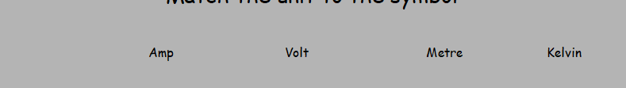
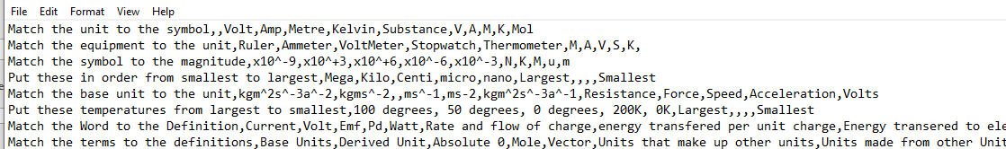
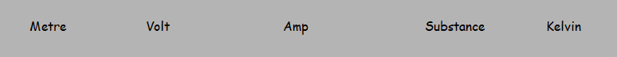
The word substance should be here to answer the question
After finding this error I checked the question3.txt file to see if there were any formatting errors and I found that in some of the questions there was an extra comma which meant that some parts of certain questions were left out
The extra commas made it, so the last answer wasn’t read in correctly and didn’t appear in the question, so I checked through and deleted any double commas
Then when I reran the code and got the same question again I seen that all of the possible answered showed this time allowing the user to answer all of the questions to be answered and to set up correctly
CA7- Whenever the timer ran out on question 5 it didn’t take the user to the quiz review form like it was meant to even though it had other times when I tested the timer.
When I checked the code I found that I had it so that if the countdown value was equal to 0 then the timer would stop and the user would be taken to the next form however when the user gets an answer wrong in this form it takes 3 seconds away from the timer which caused the timer to go into negative numbers and skip 0
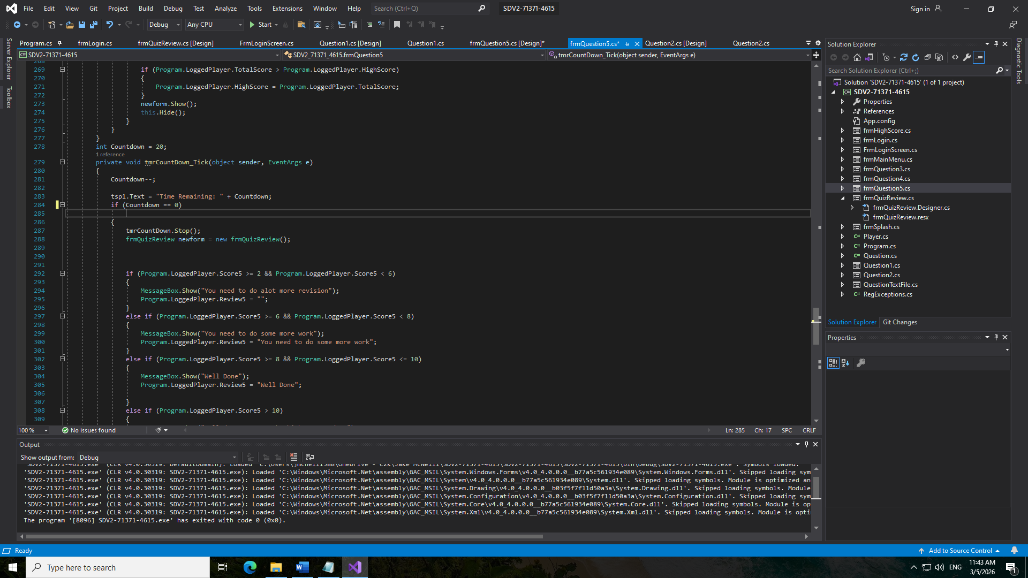
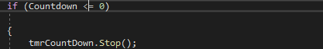
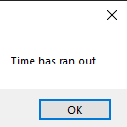
After discovering this I changed the condition in the if statement to require the countdown variable to be less than or equal to 0 so that if the user answered a question wrong when there was only 1 second left the timer would still stop and the question would end instead of going on indefinitely
After fixing the error I redid the test to see if I could still cause the error to occur and when I answered the question wrong with 1 second left it didn’t cause an error, and a message box appeared telling me the time had ran out and I was taken to the quiz review form.
CA8-The question ended earlier than I wanted it to as it was supposed to end after 15 questions, but it would end after 12 taking the user to the quiz review form not allowing them to answer the last 3 question and get more score.
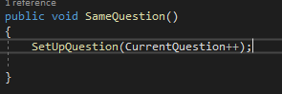
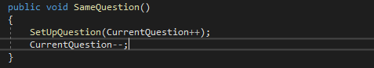
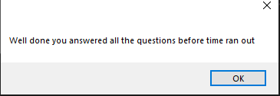
When I checked the code I found that when I was making the same question method that I used in my other questions to stop repeats I forgot to add code to decrease the current question variable by 1 so whenever the method was called it caused the current question to increase when the user hadn’t actually answered a question meaning it reached 15 before the user answered 15 questions.
To fix this error I added some code that would decrease the current question variable by 1 every time the method was called which cancelled out the incrementation that was caused by using the set up question method.
After I added this code, I ran the program again and was able to answer all 15 questions before the program showed a message box saying that all of the questions had been answered before time ran out and taking me to the quiz review form.
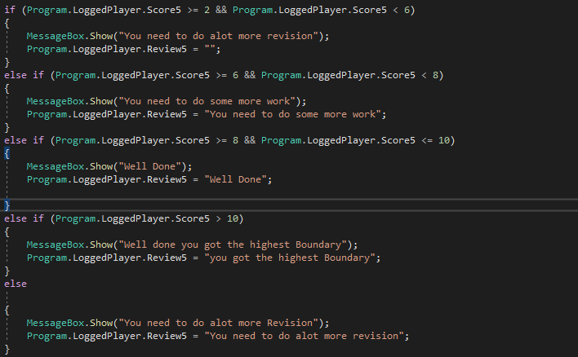
CA9- When the user completes question 5 the message box that appeared to tell the user how they did in the question gives the wrong message and gives the worst review even if the user got the highest-grade boundary for the question.
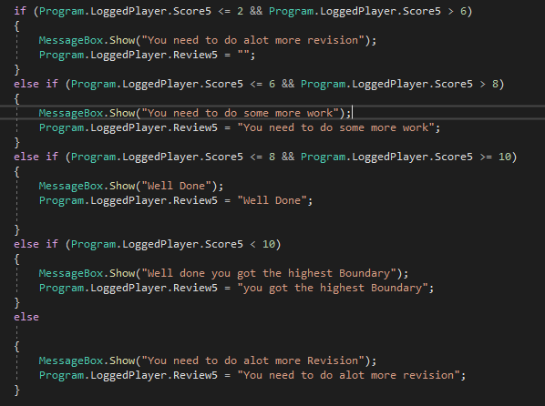
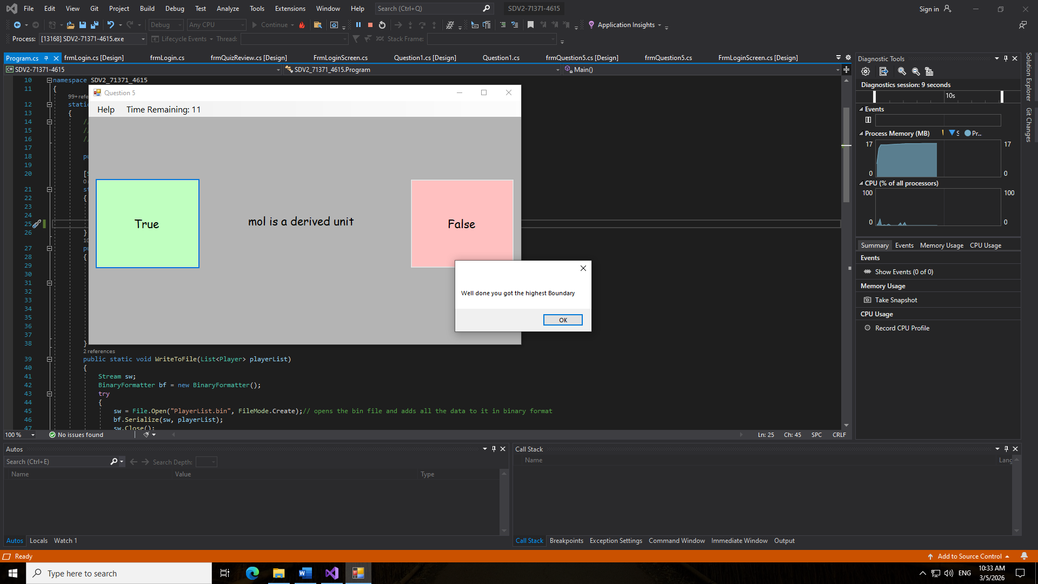
v
When the user got a score of 14 the program would still display the message in the else statement instead of the message in the else if for over 10 score, I realized that this is due to the greater that and less than symbols being the wrong way around.
After I changed the validation, I ran the code again and the correct message box appeared when I got the same score as my last test

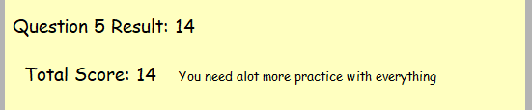
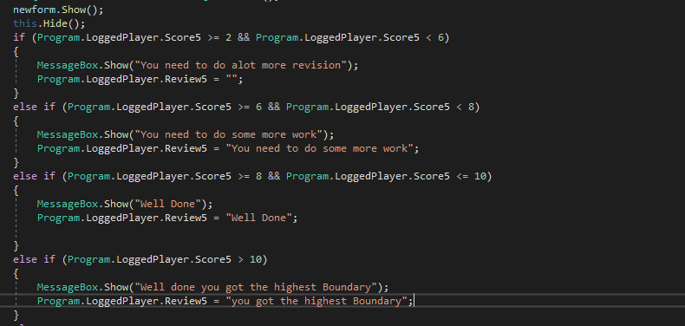
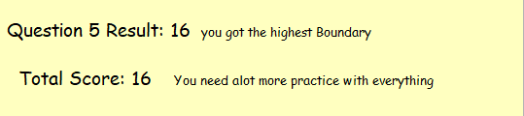
CA10-Whenever I went onto the quiz review form after completing the entire quiz it would only show me the reviews for questions 1,3 and 4 after I changed the code for CA5 the text for question 2 also started to appear.
When the when the quiz review form is opened, it is supposed to set the text to the right of the scores to the text stored in the review strings in the program class such as in the total score however it didn’t for question 5 as shown.
When I checked the code in question 5, I found out that the review variable was being set after the quiz review form was opened so the load event the was supposed to set the text in quiz review ran before the review5 variable was set causing it not to appear in the quiz review
After I changed the code, I redid the test and found that the text was now set when the form was opened allowing the user to see how they did in question 5

Evaluation

Analysis of User Requirements
All of the user requirements in the user requirements section must be met so below is a table of all of the user requirements and how I achieved them
User req. | How it was met
1 | My teacher requested that the user be able to go through the entire program in the correct order without being able to miss any part of the program this has been achieved by making sure that there are ways to go back in the program such as if the user didn’t make an account and went straight to the log in screen there is a button to allow them to go back and create an account instead of having to restart the entire program and certain parts of the program are locked until the user completes certain parts of it such as the quiz review form which has a button to access it in the main menu that doesn’t work until the user has a score for question 5 which makes it so the user can’t break the progression of the program and has to complete the entire program to get there.  This is tested in tests- 1, 3, 16, 17, 18, 27, 28, 29, 30, 33, 38, 40, 41, 42, 43, 44, 49, 50, 51, 52, 53, 54, 55, 58, 64, 65, 66, 67, 76, 78, 80, 81, 82, 83, 84, 85, 86, 88, 91, 92, 93, 94, 95
2 | My teacher requested that each student should be able to create an individual account with their own username, password and date of birth to complete this goal I created the sign up form which allows the user to enter these details along with an avatar and when they hit the submit button their details are checked to make sure that they pass the validation before the account information is saved to a binary file to be used later in the program.  This is tested in tests- 4, 5, 6, 7, 8, 9, 10, 11, 12, 14, 15, 16, 17, 18, 24, 90
3 | My teacher requested that the students should be able to interact with the program with certain keys to make this goal happen I added certain shortcuts such as if the enter key is pressed during the splash screen the timer is stopped early and the user is taken to the sign up form and in question 4 where I made the question require the user to press the arrow keys to navigate their avatar to the correct answer for the question meaning that the users have to user the buttons to complete the program.  This is tested in tests- 2, 72, 73, 74
4 | My teacher requested that I add a way for the students to receive help in the forms so that they don’t get stuck and can get through the entire program to accomplish this I added help buttons to the menu strips of every form that tell the user what they have to do on that form to progress in the program such as in question 1 the help button tells the user to select the correct answer to the question displayed in the middle of the screen and on question 4 it tells them to user the arrow keys to navigate the avatar to the correct answer.  This is tested in tests- 13, 23, 35, 29, 48, 59, 79
5 | My teacher requested that I add a way to make sure that people need their username and password to enter the program so that no one could get in without to do this I created a foreach loop that went through every username and password in the player list file until it found an account that matched the information the user gave and if they try to enter the wrong username or password it will appear with a message box telling them they entered in the wrong details before resetting the form to its original state.  This is tested in tests- 19, 20, 21, 24
6 | My teacher requested that I make sure that the user isn’t able to get stuck in the program so to achieve this goal I added buttons to each question allowing the user to go back to the main menu from almost any point of the program I also added a timer to the fifth question meaning the user will be automatically taken off the form the moment the timer reaches 0 there is also help buttons to give the user an idea of what they have to do on each form.  This is tested in tests- 22, 32
7 | My teacher requested that I make the program save the users choice of avatar and username for later use so to compete this I created an object called logged player that has all the information of the current user saved into it allowing the program to user the users avatar and username in later forms without the need to search through each user in the player list form such as in the question 4 form where the avatar is needed and in the main menu where both the username and avatar is needed.  This is tested in tests- 26, 71, 95
8 | My teacher requested that I make a way for the user to log out of the program after they are finished instead of having to close it when still logged in to do this, I created a log out button in the main menu which sets the logged user variable to null and sends the user back to the log in form.  This is tested in tests- 31, 97
9 | My teacher requested that the user be able to compare their score to other people that have competed the quiz so to accomplish this goal I made the high score form which displays each players high score on a list view and a list view in the main menu that shows the players with the top ten high scores in the player list file.  This is tested in tests - 34, 36, 37, 95
10 | My teacher requested that I allow the user to randomize parts of the program that wouldn’t affect the programs progression to do this I added a way for the user to randomize the list view in the high score form.  This is tested in test - 37
11 | My teacher requested that the questions in the first part of the quiz appear in a random order so that the user doesn’t see the same question multiple times as they redo the quiz to do this, I used the randomize list method to randomize the order of the questions in the question1.txt text file and then places the information into the corresponding labels and buttons.  This is tested in tests – 40, 41, 42, 45
12 | My teacher requested that the user be able to go back to the main menu from almost all places in the program to achieve this I added buttons on the menu strip that allow the user to save their place in the quiz and go back to the main menu at any time.  This is tested in tests – 46, 56, 69, 75, 93
13 | My teacher requested that the user should be able to drag and drop answers into slots during some of the questions in the quiz so to fulfil this request I added drag and drop mechanics that allow the user to place picture boxes and phrases into certain spots on the form that saves the users answers so that they can be used to check to see if they got the correct order when the user presses the check answer button.  This is tested in tests – 49, 50, 51, 53, 54, 55, 60, 61, 62, 63
14 | My teacher requested that I make sure that the random questions don’t cause the user to be asked the same question multiple times in a row so to accomplish this I created an if statement that checked to see if the text of the last question matches the text of the current question and if it does it calls the same question method which sets up the question again and doesn’t affect the current question number meaning the user will still be asked the same amount of questions.  This is tested in tests – 78, 80
15 | My teacher requested that I make sure that the user is told what is wrong with their details if they get an error when trying to create an account to achieve this I made it so that all of the validation gives its own unique error message such as if the password doesn’t have a capital or if they haven’t selected an avatar allowing the user to know what to change the next time they try to create an account.  This is tested in tests – 5, 9, 12
16 | My teacher requested that the program be able to reset the questions as the user answers them to allow for it to be more seamless and to stop the user from having to lock in their answer for every question to do this I created the set up question method that takes in the current question number and takes the next question from the text file and sets it up in the form for the user to answer.  This is tested in tests – 41, 42, 52, 66, 78, 81, 82
17 | My teacher requested that for simpler question types like true or false question the user should have a certain amount of questions they need to answer but be timed to see how many questions they can answer before the time runs out to make it more challenging to achieve this I added a 20 second timer to question 5 and whenever the user answers a question wrong it takes 2 seconds away from the timer and if they answer right they gain 2 seconds and when the timer reaches 0 it stops the question.  This is tested in tests – 83, 84, 85
18 | My teacher requested that the user be told if they achieved a new personal high score when they compete the quiz so to accomplish this I made code that added up the users total score and then compared it to the high score in the logged user object and if it is greater a message box appears telling the user that they achieved a new high score and replaces it in the player list file.  This is tested in test – 91
19 | My teacher requested that the user be told how they did in each question on the quiz review form to accomplish this I created 5 new variables in the player class review1 to review 5 that save a different string of text for each question depending on how the user did in each question which is then displayed next to the scores in the quiz review form.  This is tested in test – 94
20 | My teacher requested that the user gets told how they performed in each question after they complete it to accomplish this, I made an if statement which checked how well the user performed by using their score for that question and depending on what they got they will get a different message.  This is tested in tests – 47, 57, 68, 77, 89
21 | My teacher requested that the user should be able to go back to where they left off in the quiz when they went back to the main menu to accomplish this I created a variable that changes depending on what form the user was on before they went back to the main menu and is used to decide where the user should be sent when they hit btnReturn.  This is tested in test – 32
22 | My teacher requested that I allow users to keep their log in details private so to accomplish this I added a feature to the log in screen that hides the user password as they enter it allowing them to enter it without others being able to see it.  This is tested in test – 25
23 | My teacher requested that I allow the user to close the main menu through the menu strip so on all of the forms that contain a menu strip the user can now open the file drop down menu and close the program by hitting the close button.  This is tested in test – 93
24 | My teacher requested that I allow the users to be able to keep track of their score throughout the quiz. To accomplish this goal I added a label to the menu strip in the question forms that constantly displays the users high score  This is tested in tests - 90, 91

Survey Feedback
Most of the reviews for the questions were good however there were a few bad reviews for the drag and drop questions this could be due to the slow nature of the questions requiring the user to precisely drop the correct answer into the correct slot which could take some time so I will look at improving this aspect of the quiz. I could also mitigate this problem by making it so the user doesn’t have to answer as many questions on questions 2 and 3 than they do on the rest of the questions such as the user only has to answer 3 questions on questions 2 and 3 however they still have to answer 5 questions on questions 1 and 4, when making this change I would also need to consider dropping the total grade boundaries so that they match up will the new max score that the user could earn.
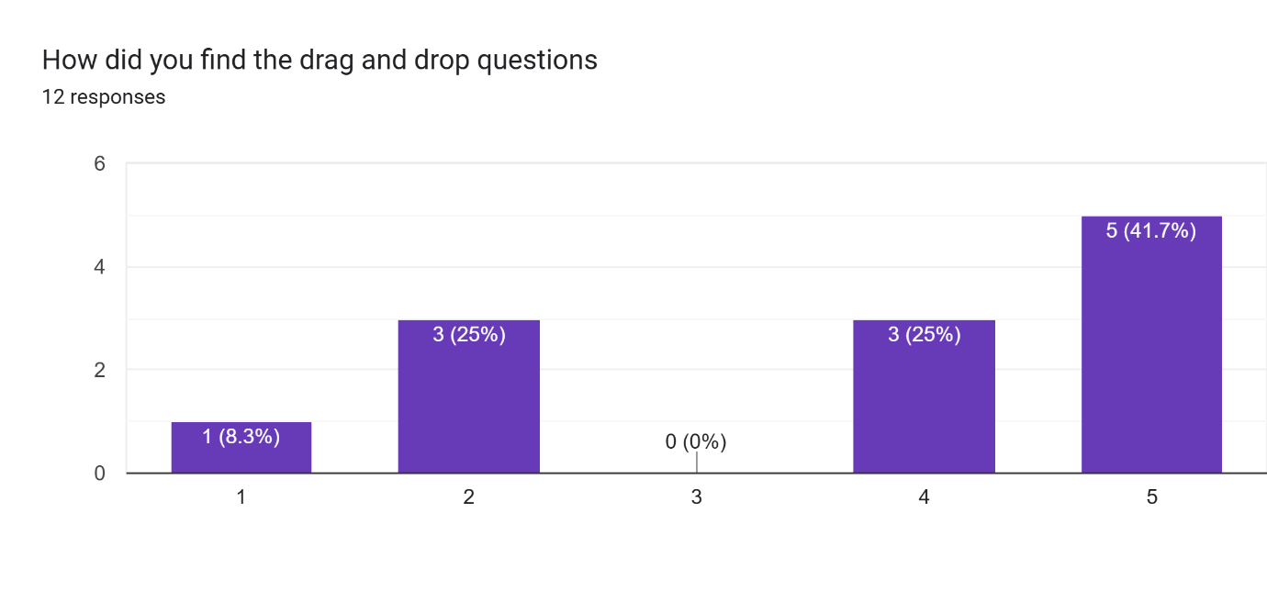
There one or two reviews that said they would have liked to have seen more game like questions in the quiz that would have made it more enjoyable. I will look into different game shows to see if there are any styles of questions that I can implement into the quiz to make it more enjoyable for the end user. I could also use this feedback to add to either question 2 or 3 with a new game show-based mechanic that would be more challenging to the user and make the question more enjoyable which could improve the reviews that questions 2 and 3 got.
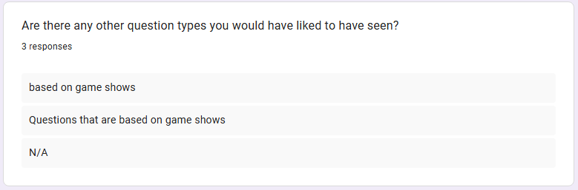
There were also a few responses that requested that I make better use of menu strips to allow the user to navigate the program better as currently there is only a way to go between the main menu and the questions and from the main menu to the quiz review after question 5 has been complete. To improve this I will consider adding more functionality to the menu strip such as making logging out more accessible by adding a function to the menu strip that allows it to be done from more forms than the main menu and adding a way for the user to close the program
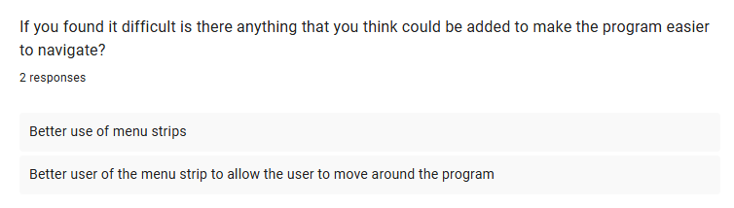
The help provided in the forms was deemed useful by a majority of the users however there were still a lot of people who didn’t find it useful or who didn’t use it at all knowing this I will look into improving the help message boxes and find a way to incentivise people to use the help button if they are stuck. I will consider adding a message to one of the forms that makes the user aware of the help.
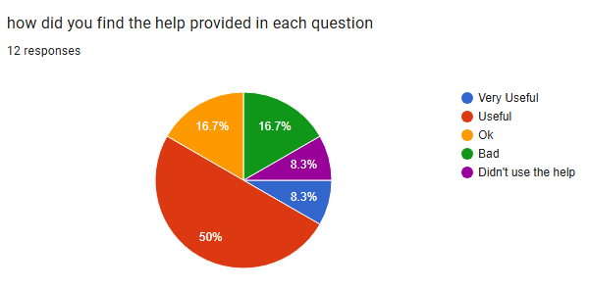
There were a few responses that gave the ability to navigate the program a 3 out of 5 so I will look into making the program easier to navigate for the user to make sure that nobody gets stuck in the program. By making sure that the buttons that bring the user to new forms are all clearly labelled so that the user knows where each button will take them. I could also add more functionality to the menu strip so that the user can use it to navigate throughout the program with the menu strip instead of constantly having to go back to the main menu.
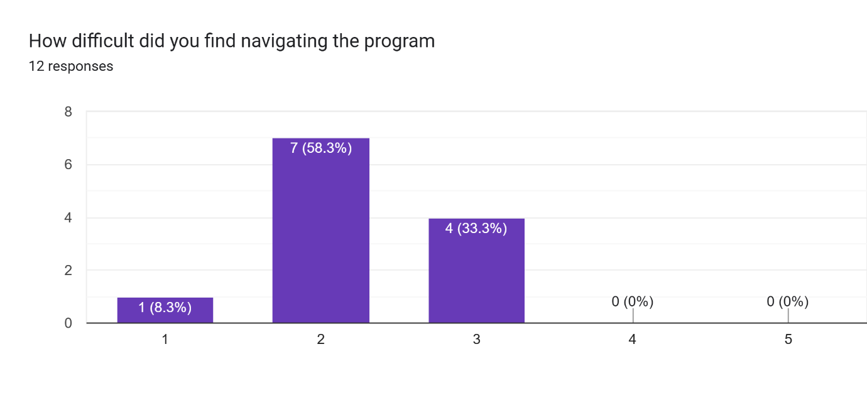
The look of the program was overall looked on fondly by the majority of the users however there were still some reviews that requested that I add more colour to the program to make it more visually appealing to achieve this I will look into adding more colour to the form itself and not just the buttons on the form. I believe that I can also accomplish this by adding more colourful panels to each form that can hold information and make the forms look cleaner. I could also replace the grey background colour with another colour that matches better with the more colourful panels and use different colours of text to make sure that none of the text is too hard to see on a different coloured background.
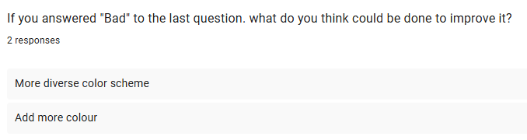

Strengths
When making this program I believe that I did very well on many aspects such as creating a good sign-up process for the user which gives them a lot of freedom in creating their profile such as what avatar they want to use and allowing them to all have their own unique usernames.
I also think that I did well on the switch to the log in screen telling the user what is wrong with what they entered or showing a different message box if the user didn’t enter any information telling them that they didn’t enter anything and that they need to input a username and password to log in. I am also proud of the code that saves the current user if the user had just created an account and auto fills in the username and password textboxes with the correct information allowing the user to save time.
I also think I did a good job handling the layout of all the forms to make them all unique and different from one another along with spacing out all of the information to make none of the forms feel too crowded with information.
When creating most of the questions I made sure to make them all fair so that the user should be able to answer all of them without too much trouble and I am also happy with the features that I added to make sure that the user couldn’t just guess answers in the true or false timed question by making the program take away a lot of time for each incorrect answer.
I also feel like I succeeded in making sure the user knows how they did in the quiz by giving separate message boxes at the end of each question telling the user how well they answered it based of the score that they achieved and on the quiz review where it congratulates the user if they achieve a new high score and by showing what score they got in each question on the quiz review form. There is also the high score form which allows the user to compare their score to others and the top ten list on the main menu that will incentivise user to try and score as high as possible to get on the list.
I believe that I did a good job at making a fair scoring system as for questions 1,4 and 5 the user gets 2 score for each question that they get correct which I believe is fair as they are the easiest questions in the program that are multiple choice and true or false. Whereas in questions 2 and 3 the user gets 3 or 5 score for each question that they get correct as the drag and drop require more effort to complete the questions as for each of them the user has to organise 3 or 5 labels or picture boxes into the correct order which has a lot more risk as if the user fails to get them in the right order they lose all of the score.
I also believe that I did a good job at utilising if statements when making the program so that depending on how the user has used the program different things will happen such as if the user goes onto the log in screen without first making an account, they will have to log in normally and fill in the username and password themselves. However, if the user did just create an account when they move to the log in screen the program will check to see if the logged player variable is not null and if it isn’t null then it sets the text inside of the username and password textboxes to the username and password that the user just made so that they don’t have to enter it again. Or on the main menu where if else statements are used to find out what avatar the user selected so that it can be displayed. There is also at the end of every question the program puts the user score for that question into if statements that check to see how the user preformed in that question and gives them a different review for the quiz review based on the score.

Weakness and Improvements

Improvement 1
After seeing the reviews left in the quiz, I have decided that I need to change either question 2 or 3 as both have similar mechanics and had the worst reviews of all the questions in the quiz. I also received reviews telling me that I should make more unique questions potentially based off game shows, so I plan to replace either question 2 or three with a multiple-choice question where the user has a finite number of lives and has to get as many questions correct so that they don’t lose all of their lives and end the question early it will force the user to think more before they answer and I believe that the user will enjoy the increased risk brought by the chance of losing lives if they get an answer incorrect. Overall, I believe that adding more questions based off game shows will make the quiz more unique and I look forward to seeing what people think of the new questions that I make to replace some of the more menial questions such as the drag and drop questions.

Improvement 2
Another weakness I noticed when checking the code is that the password is displayed unlike most other programs and websites that hide the password of the user for security
Original code
The original code had no way to hide the password of the user as at the time I didn’t know how to accomplish it
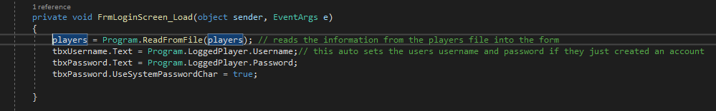
New code
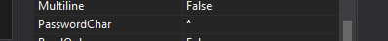
The new code allows adds to the load event and allows the program to hide the password by using the UsesystempasswordChar and setting it to true.
Now whenever the user enters their password all of the letters will be replaced with a star to allow for more privacy in the log in screen and to stop other people from seeing other users log in details and logging into their account.

Improvement 3
Because the user requested that I make better user of the menu strips I decided that I would add a way for the user to log out and sign out from all the places in the program that allow the user to access a menu strip.
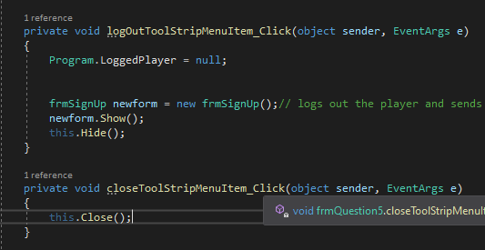
New code
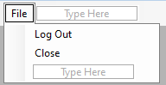
The new code allows the user to log out or close the program from almost all of the forms after the log in screen with the exception of the quiz review as it lacks a menu strip to add to.

Improvement 4
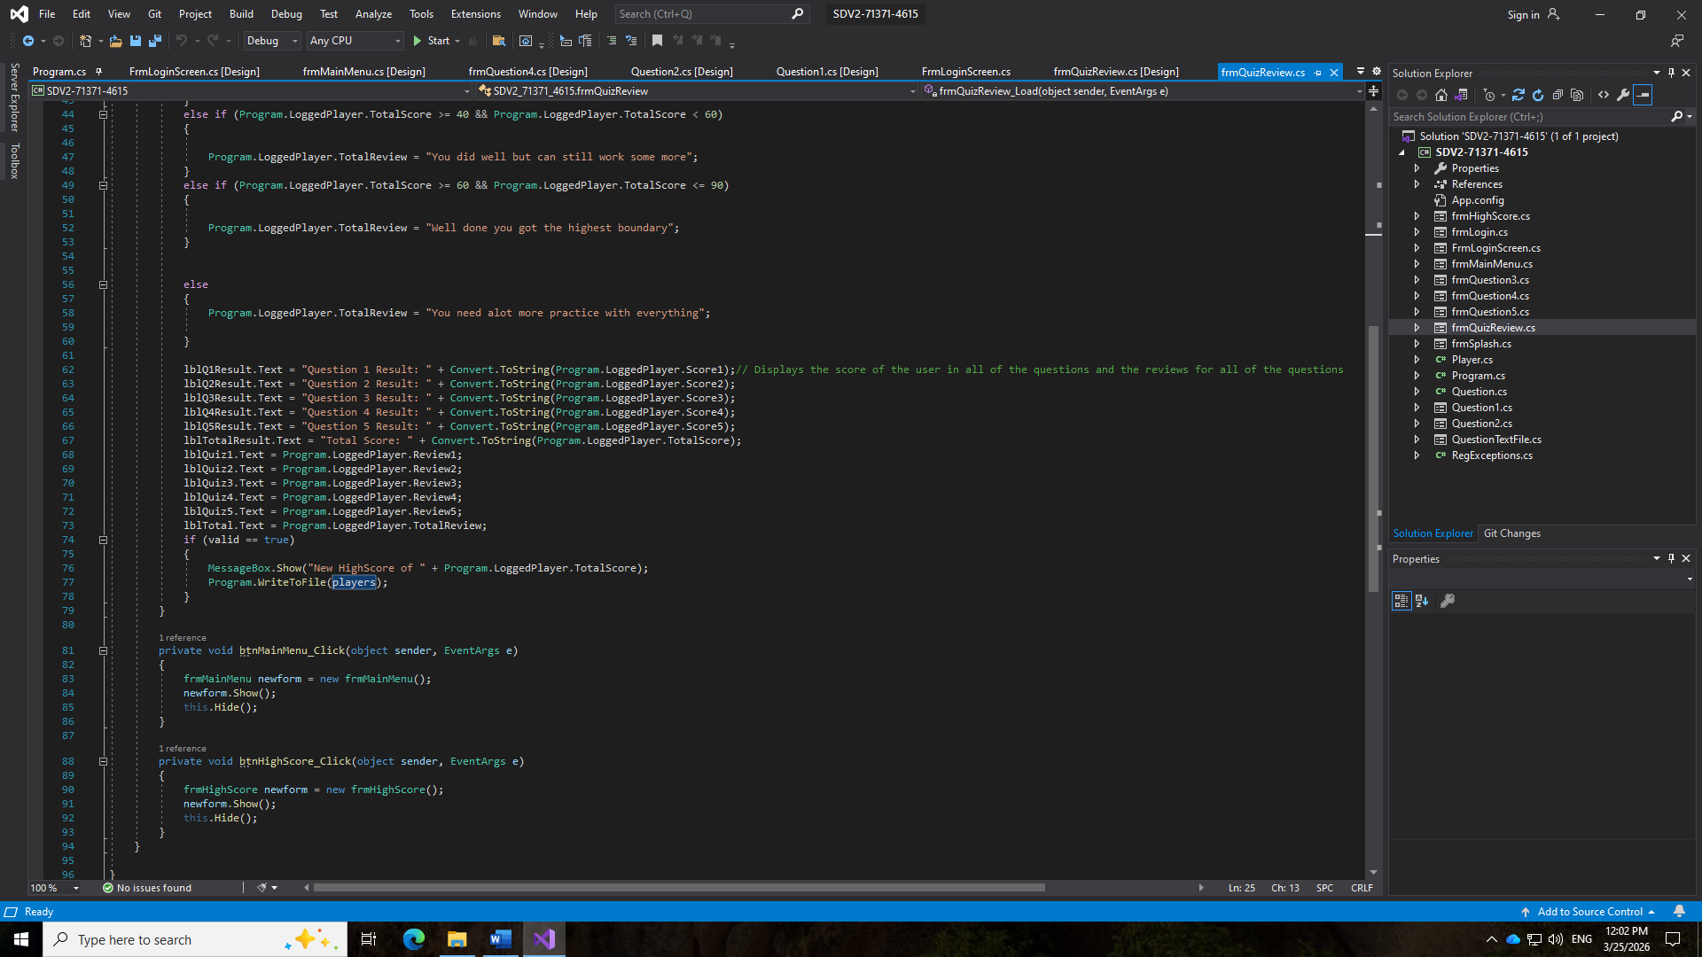
I also am considering adding a way for the user to save their progress so that if they log out or close the program the progress will be saved, and they can continue from where they left off when they closed it. I plan to achieve this by adding a button to the menu strip that saves the current logged user and replaces that user in the file with the logged user. This will help the program as it will allow the user to keep certain parts the logged user variable the same such as the last form variable so that when the user reopens the program, they can use btnReturn on the main menu to go back to where they left off in the quiz and not need to start from the beginning again. This could be done with the same method that is used to change the user in the bin file whenever updating their high score.

Improvement 5
After testing question 5 I realised that the reason why some people may have not found the help message boxes useful was because in certain questions like question 5 when the user clicked the help button the timer for the question would continue to decrease so there was no point as they were spending time that could be used to answer the question reading how they should answer the question. To fix this I added code that stops the timer when the help message box appears and added code that runs after the message box is closed that starts the timer again so the user doesn’t have to waste time when reading the help.
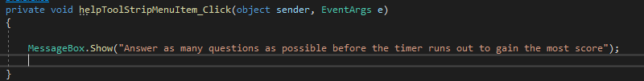
Code before
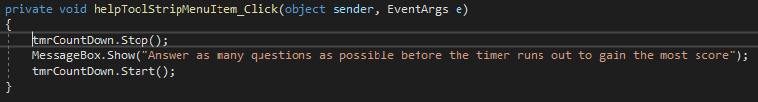
Code After

Time Management
When developing this program, I noticed that I spent a lot of time on certain parts of it that may not have needed it. For the sign up form I feel like is spent a lot of time trying to make it visually appealing however if I could go back I would have spent this time adding more validation as there are still something that I would have liked to be possible such as a way for the user to have to confirm their password and allowing the user to have a larger selection of avatars to choose from aside from the 4 that I added at the start.
Another thing I spent too much time on was the formatting of the forms as I made a form I would then realise that it didn’t have the room to hold the text that was being displayed so I had to spend a lot of time moving labels and testing them that could have been spent creating more questions to be displayed in the questions as currently there is only around 10 questions available for each form meaning that there is a high chance that if the user goes through the quiz a second time they are very likely to come across a question that they have seen before.
One of the forms that I spent a lot of time on was making the fifth question as there were a lot of ways for the user to break the form and allow them to get an unfair advantage such as if the user timed a wrong answer with the timer reaching 1 second then the countdown would go into negative number and never pass the if statement to check if it equalled 0 I could have spent this time doing more testing to make sure that there no remaining issues.
I felt that I managed my time well when creating the rest of the question form as I got them all done in a reasonable amount of time though if I could have I would have liked to add greater functionality to the menu strip as currently it only allows the user to access help, return to the main menu from the questions, display the timer for the fifth question and allow the player to close the program or sign out if I could I would have liked to add features such as a way for the user to access the high score form at any time from any of the forms after the log in screen or a way for them to change their avatar so they aren’t stuck as the avatar that they chose when they initially created the account.
Additionally, if I had more time, I would have liked to add a feature that would have checked all the previous questions the user had been asked on a form with a while loop to stop the user from being asked the same question twice on the same form.
Some time that I could have spent on coursework I had to spend practicing music as I play piano outside school and had a grade 7 exam in December so instead of doing code at home, I had to spend that time practicing my piano however if I didn’t have my exam I would have used the time that I would have gained to make my program more visually appealing as it would help to fix the problem that so users had with the design of the program that they left in the reviews
I also had to spend a lot of time revising for Christmas mock exams that I could have spent doing more code and correcting errors if I didn’t have to do as much work for this and could have used it to improve my code, I would have used it to add more functionality to my menu strip as currently it can only be used to go from the main menu to other question forms and for the user to log out and close the program.

Skills Development

Writing to and reading from bin files
During the production of the program I had to learn how to save information to a bin file and how to read that same information from the bin file at later points in the program I first created a method that would open the player list file and then add the information to it and I there was no file it would create the file in the program bin file and add the information to that file.

Reading questions from a .txt file
When making the questions for the program I had to find out how to read the questions in from the text file that the questions were saved on so I had to learn the proper formatting of how to create question and make an array object will the information inside of it so the program could successfully create the questions and then the player could then be asked a question with the correct answer.

Drag and drop
Before making this program, I hadn’t used to drag and drop mechanic before so I had to learn how to allow the user to drag certain picture boxes or labels onto other empty spaces and save the answer that the user selected into an array that would be checked against the correct order of the picture boxes or labels.

Movement keys
I had to learn how to make the program read the inputs of the user to allow it to pick up whenever the user pressed any of the arrow keys so that they could move their avatar to the correct answer in the question 4 from after finding out how to do this I added a feature to the splash screen that allowed the user to press the enter key to skip the 5 second wait to see if I had learnt how to use inputs to affect the rest of the program

Validation
I learnt how to add additional validation to the sign-up process making sure that the user couldn’t create an avatar with a username or password over 20 letters long or a username or password which was under 8 letters long. I also used this new knowledge of validation to make sure that the user couldn’t create an account if they were under 16 or if they were over 26 and make sure they couldn’t create a user without having selected an avatar.

Load Events
When creating the code for the program I had to learn how to order the code correctly so that certain variables are set before the next form opens as there were multiple parts of the program that didn’t function correctly when I tested it due to the order of the code and variables not being set before the next form opened. Some examples are the review for question 5 didn’t display in the quiz review form because the code for setting the review text ran after the quiz review form was opened.

Appendix

Blank Survey
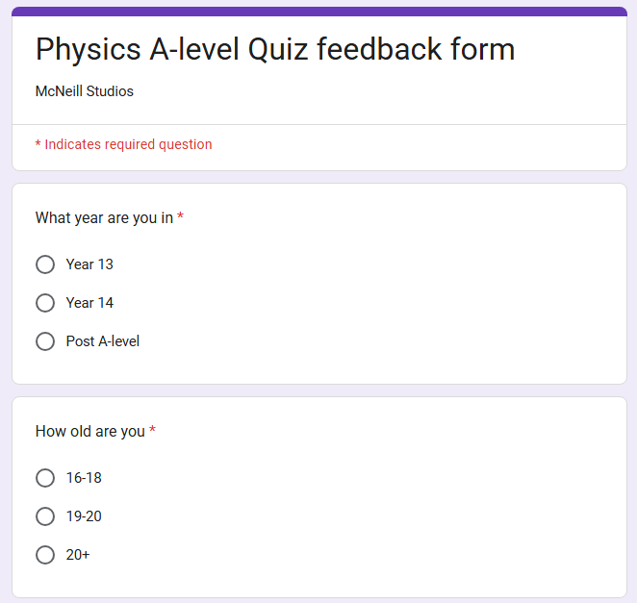
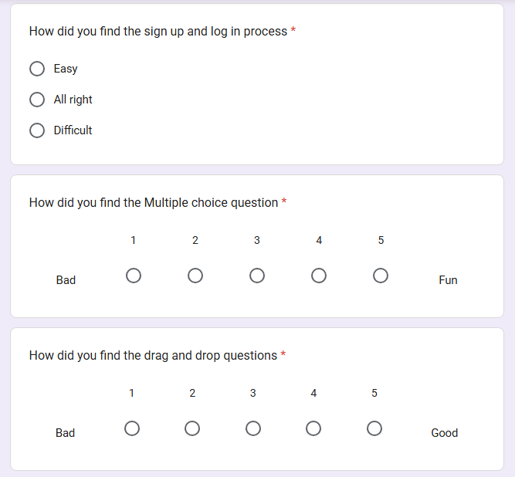
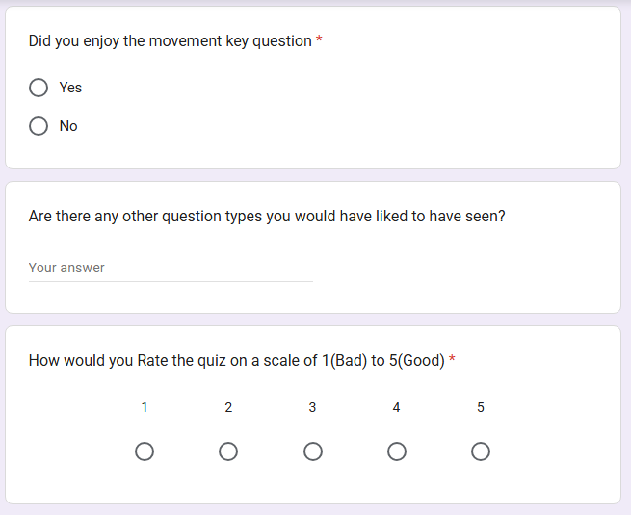
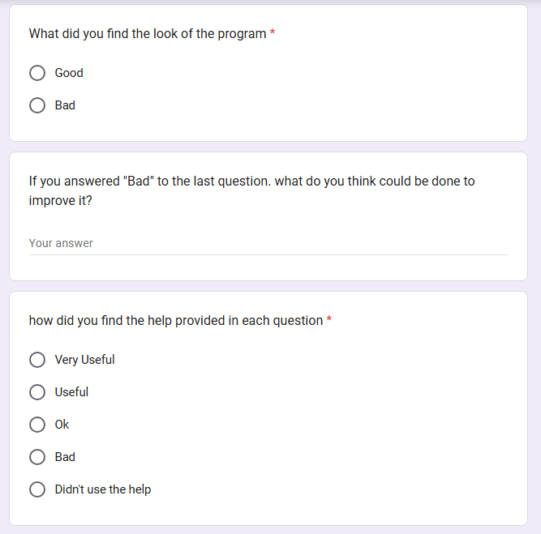
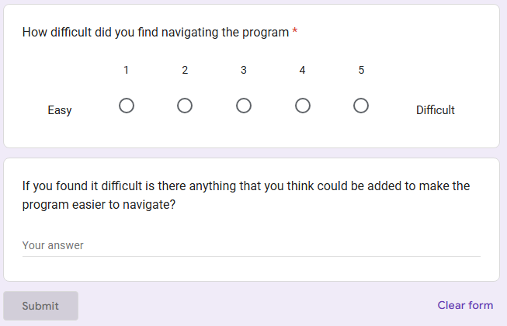

Completed Surveys

End User surveys

Survey 1
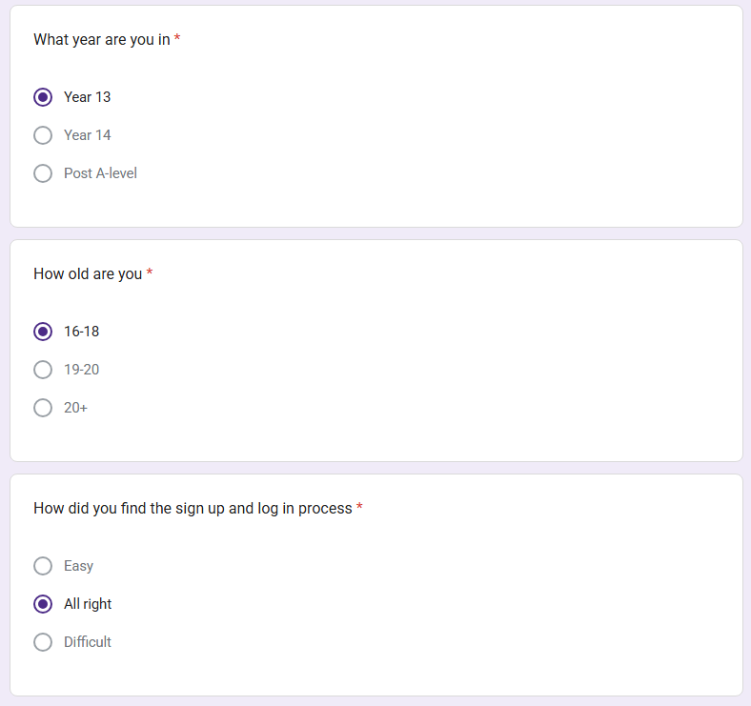
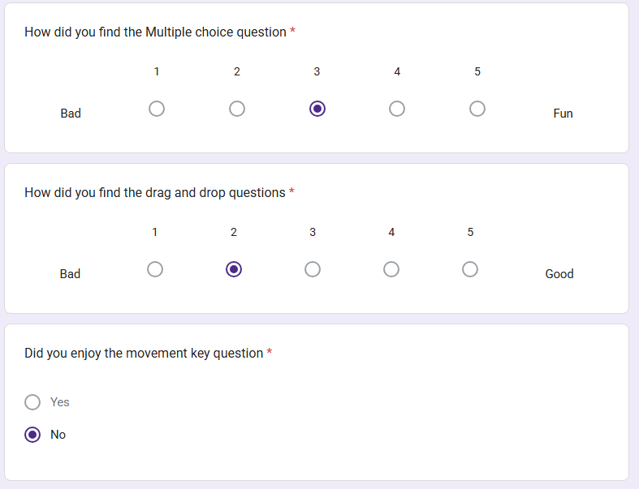
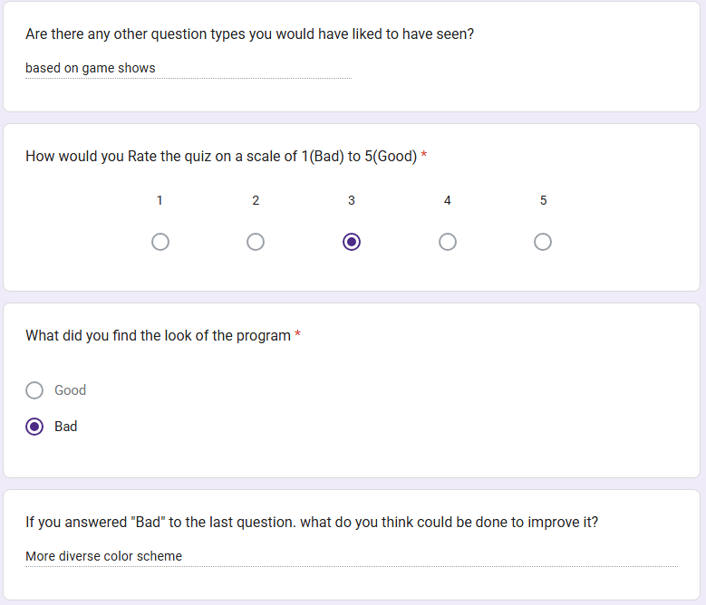
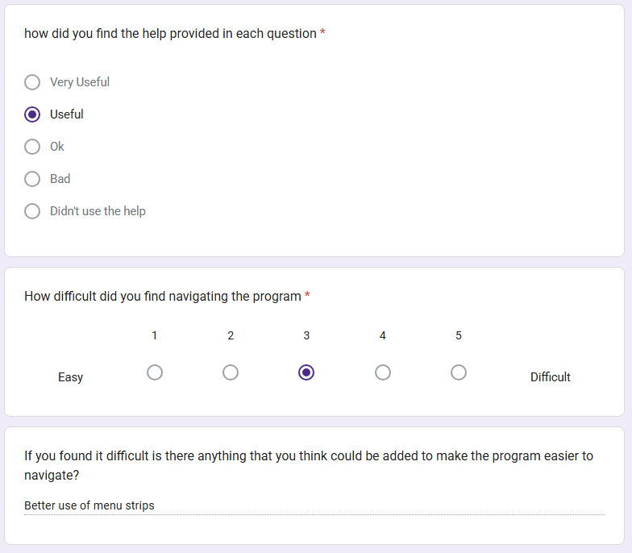

Survey 2
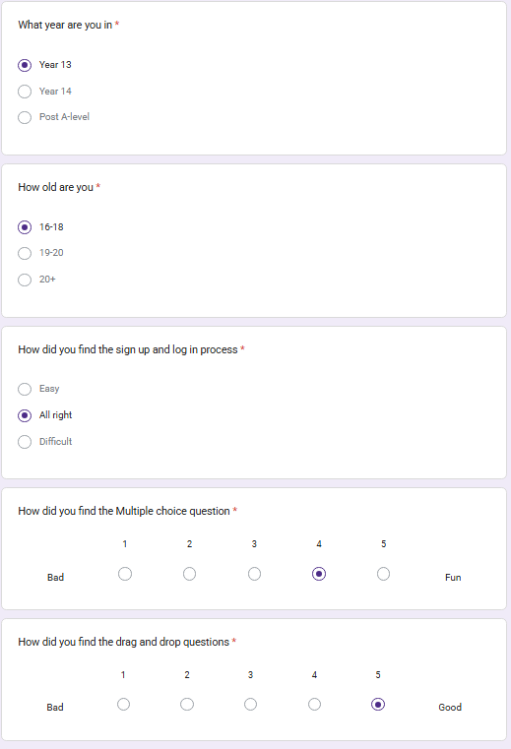
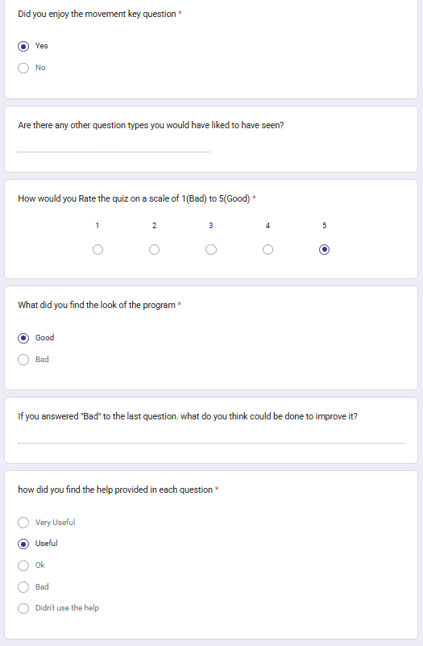
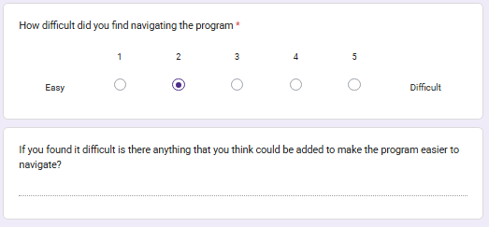

Survey 3
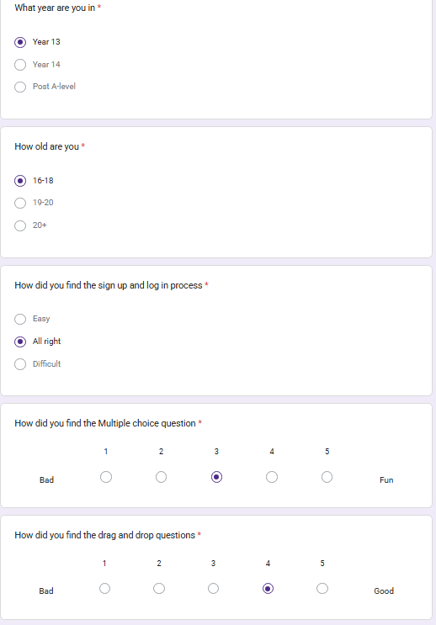
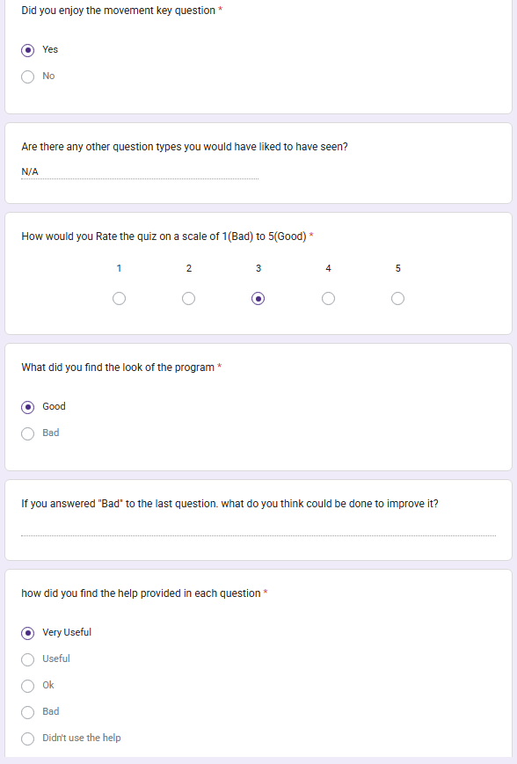
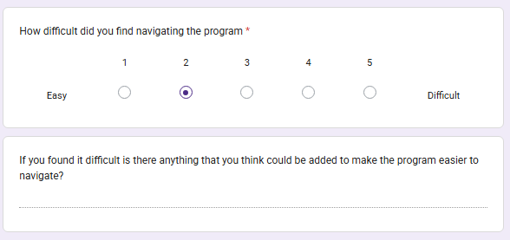

Survey 4
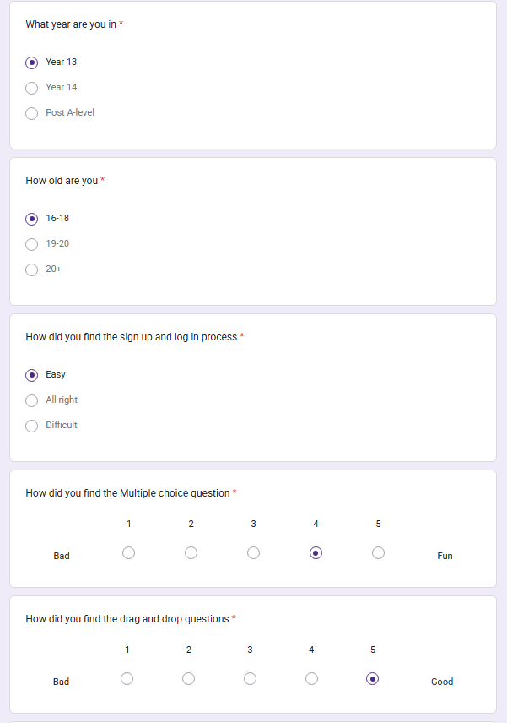
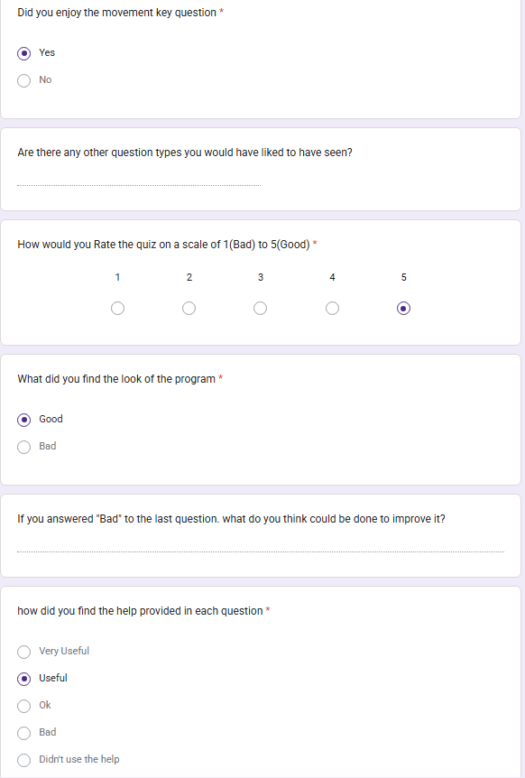
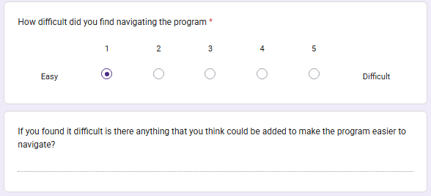

Survey 5
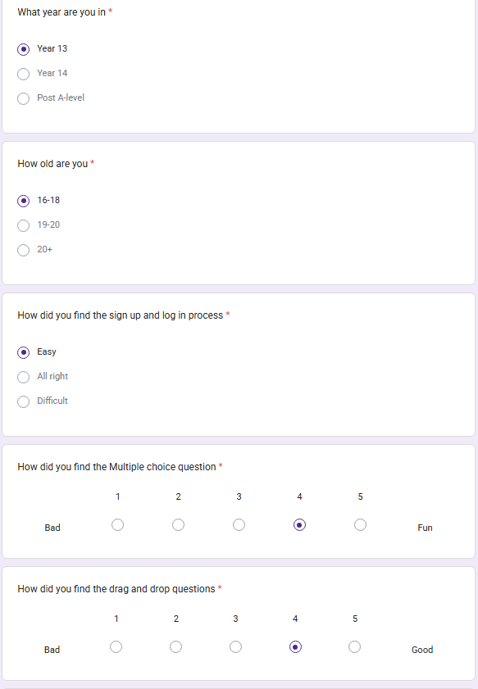
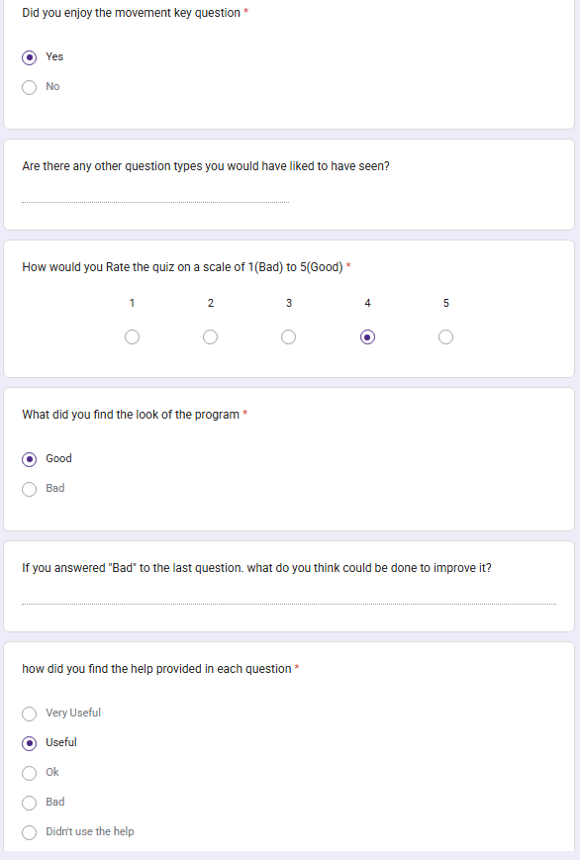
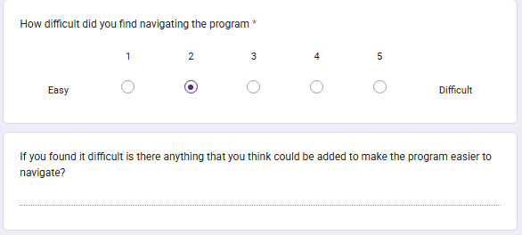

Survey 6
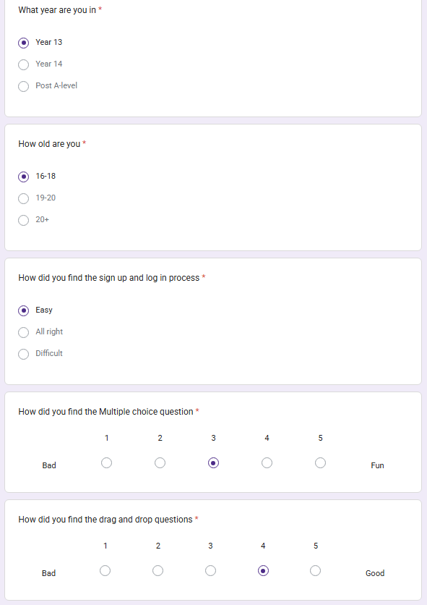
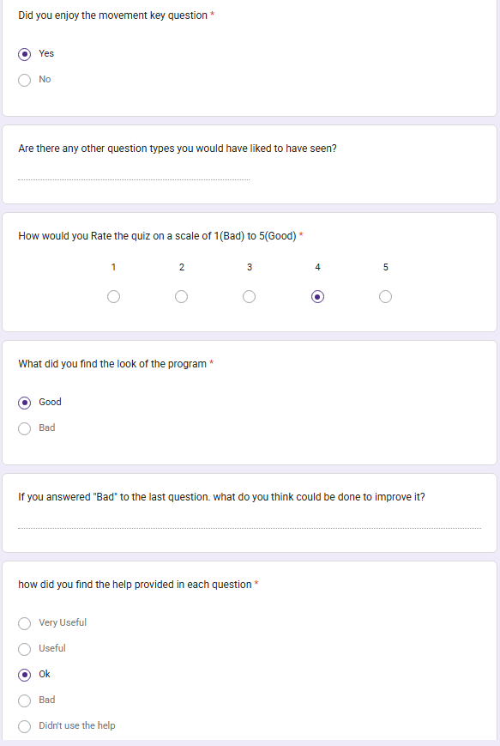
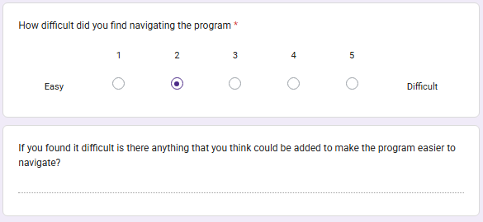

Survey 7
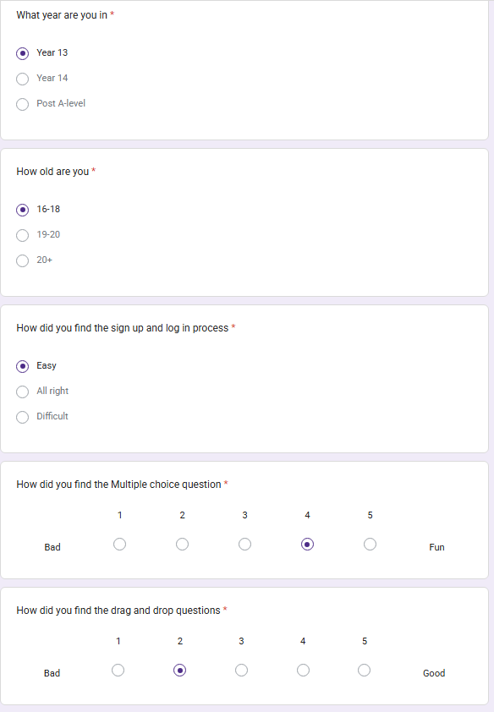
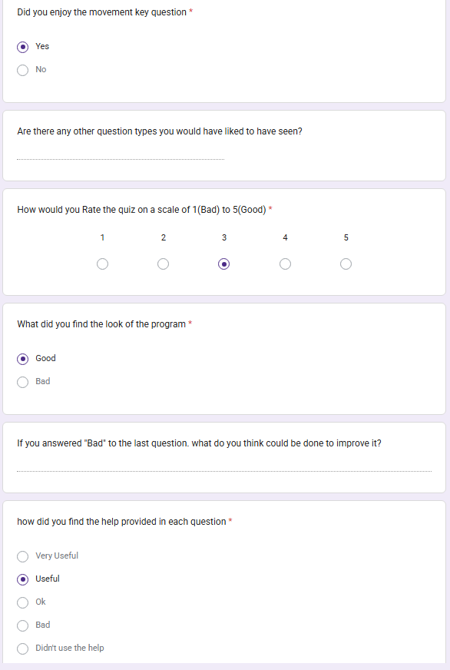
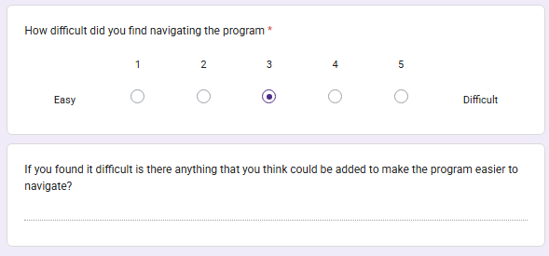

Survey 8
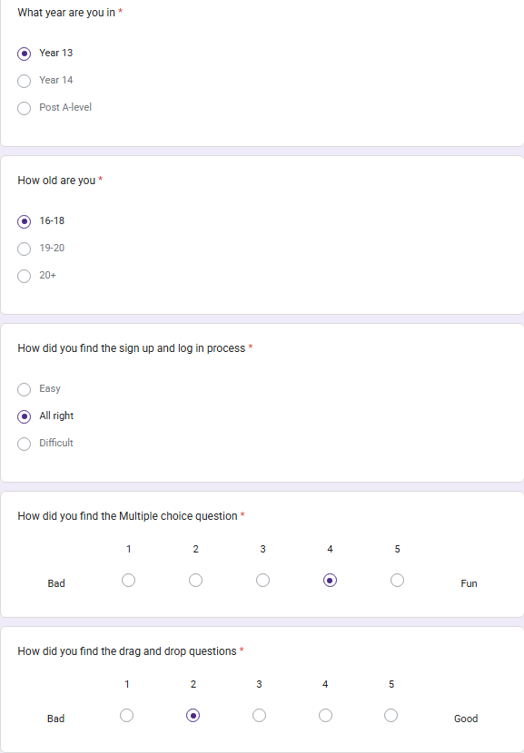
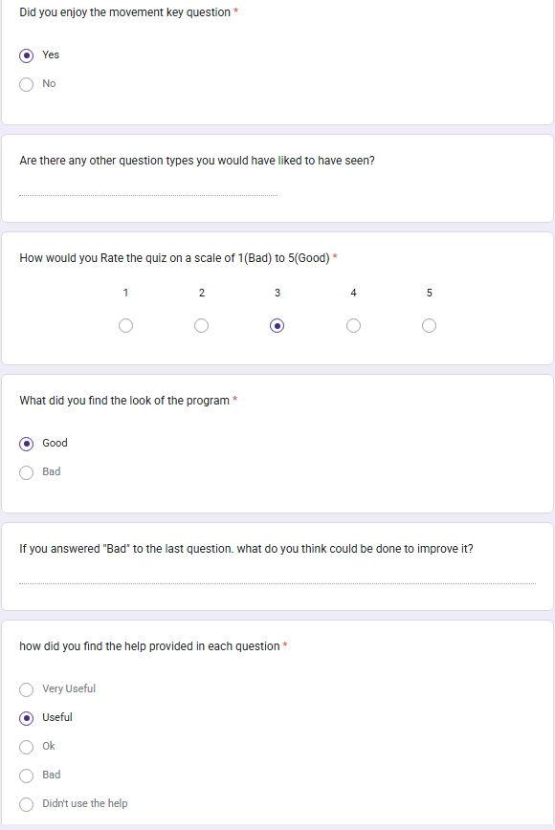
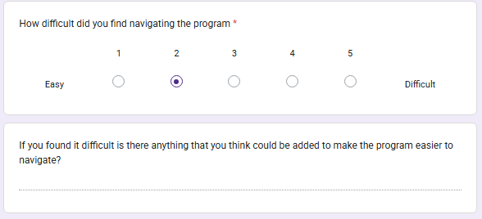

Survey 9
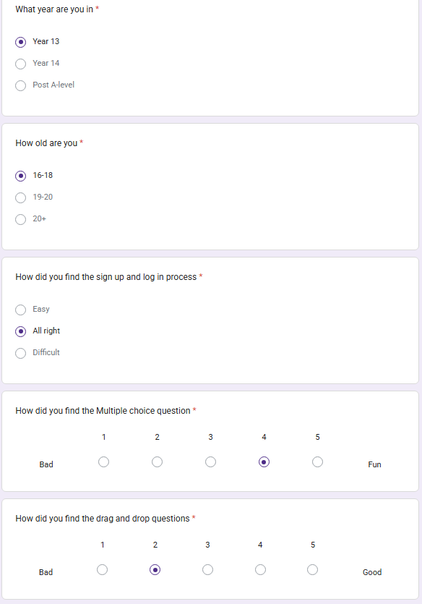
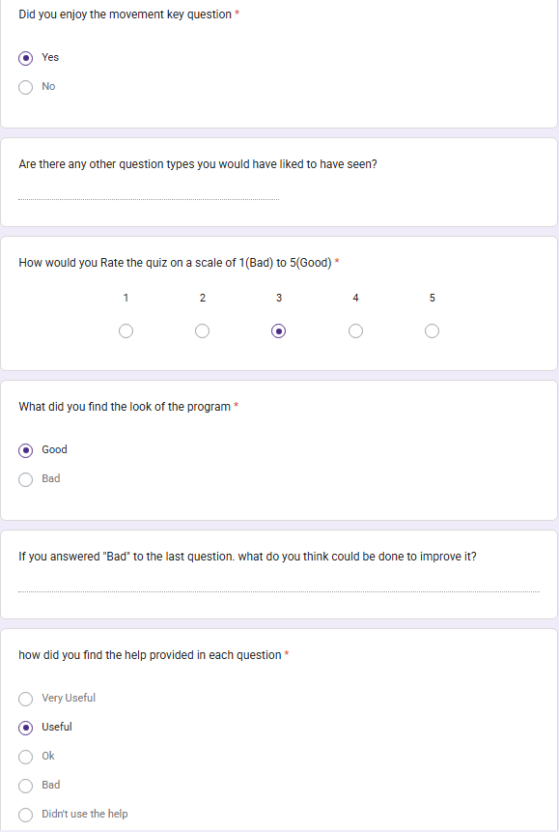
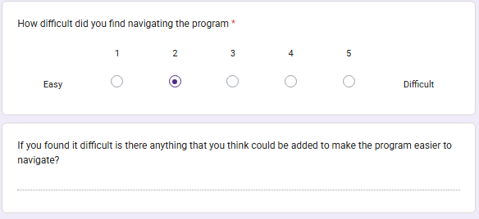

Survey 10
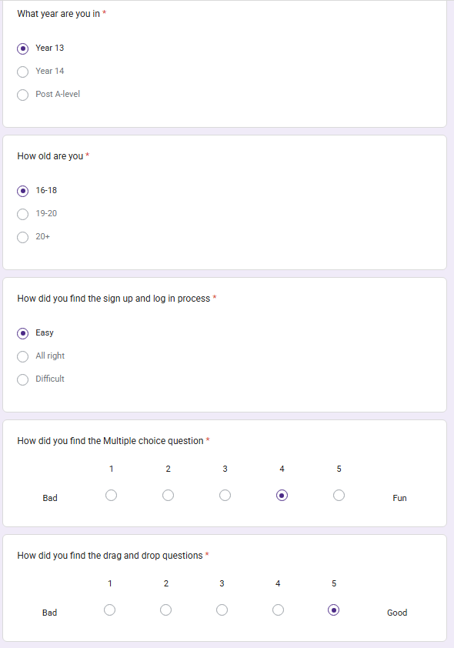
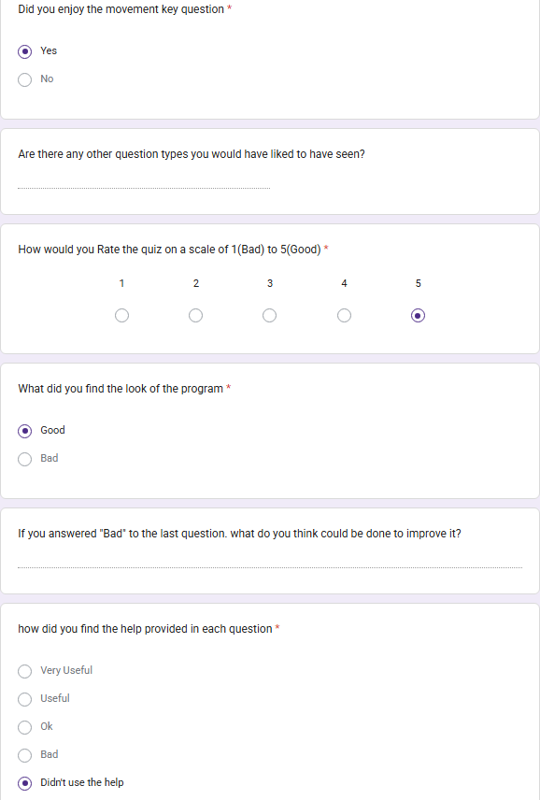
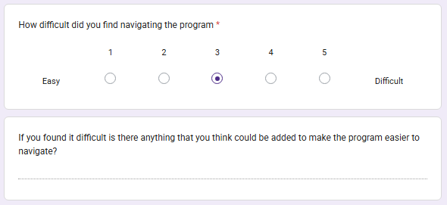

Survey 11
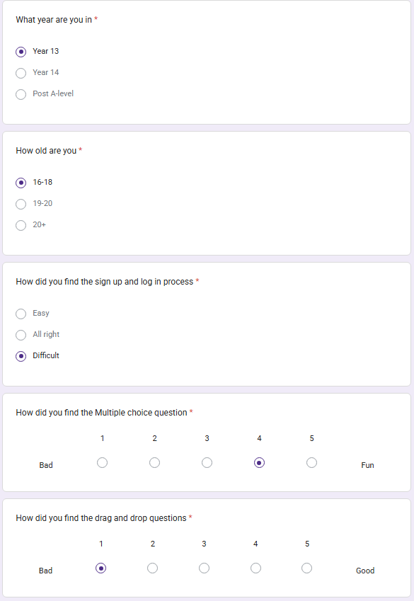
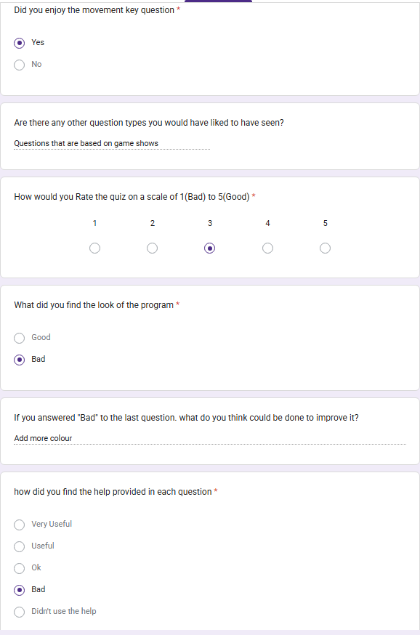
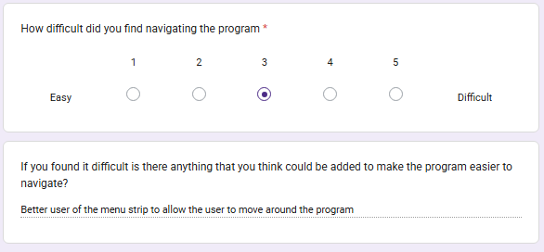

Client Survey
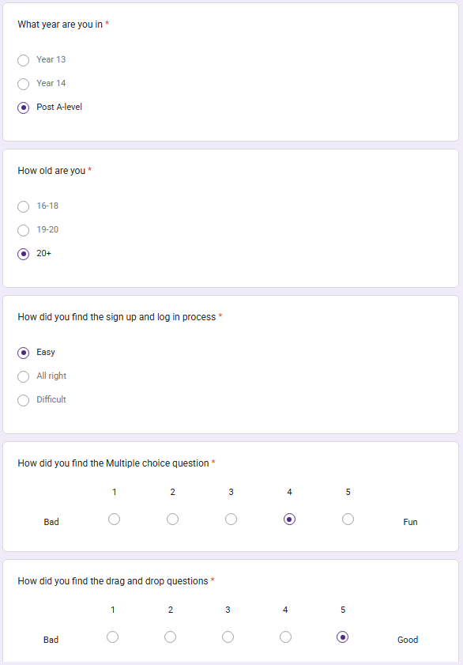
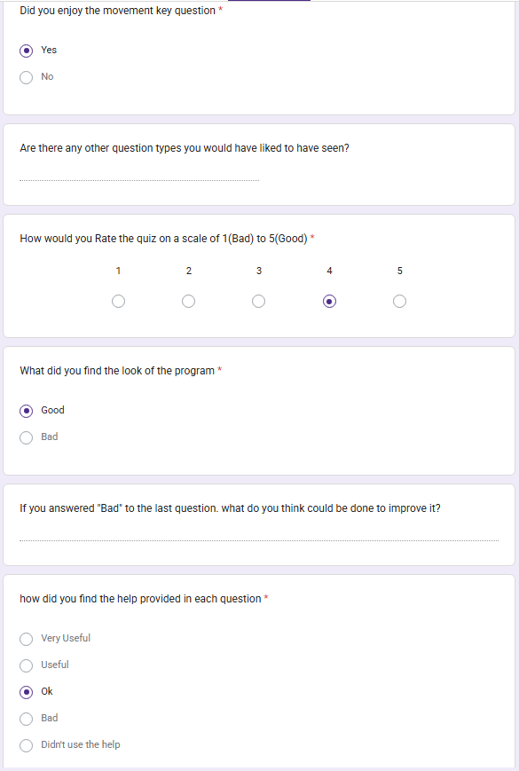
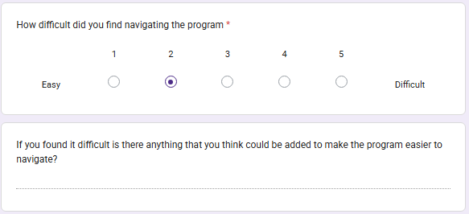

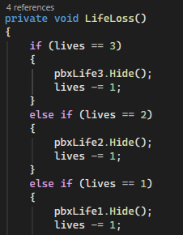
Post Deadline Changes
Change 1 – Added Lives to question 1 and increased the amount of questions asked to make the question more interesting

To create the lives I add a new counter to the code for question 1 which started off as 3 and every time the user answered a question wrong a method would run that would change the value by -1 and when the value reached 0 the player would receive a message telling them that they ran out of lives and would be brought to the next question.

To allow the user to know how many lives they have remaining I added 3 heart images to the question whenever the user gets a question wrong one of the hearts disappear until none are left.

All lives remaining:


Only one life remaining:

The reason that I made this change is because I found out that I lost marks in the coursework due to some of my questions not being game like and adding a lives system is a good way to make it more like a game when you only have a certain number of chances to answer all of the questions. It also adds more risk to answering as before you could still answer all of the questions even if you got one wrong but now you cant answer any more than 2 wrong without being taken to the next question right away

